**Volume 46, Issue 3**

**irch 2000**

**The security world is plugged in and on-line! From cyberspace to service calls, electronics have become a vital part of the industry.**

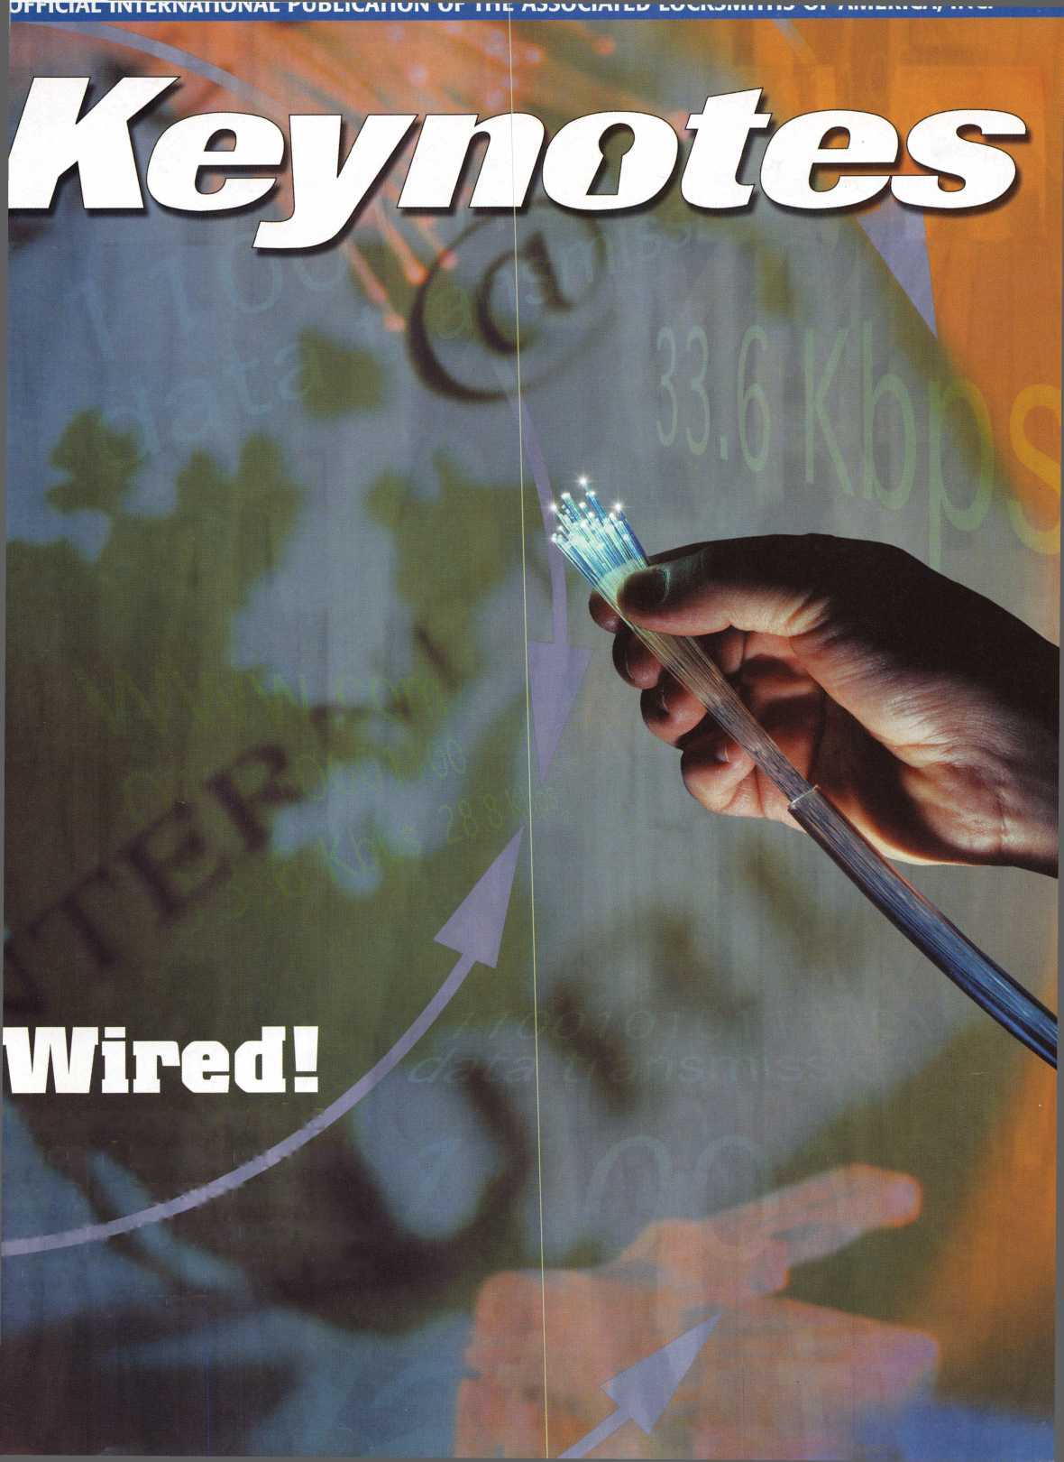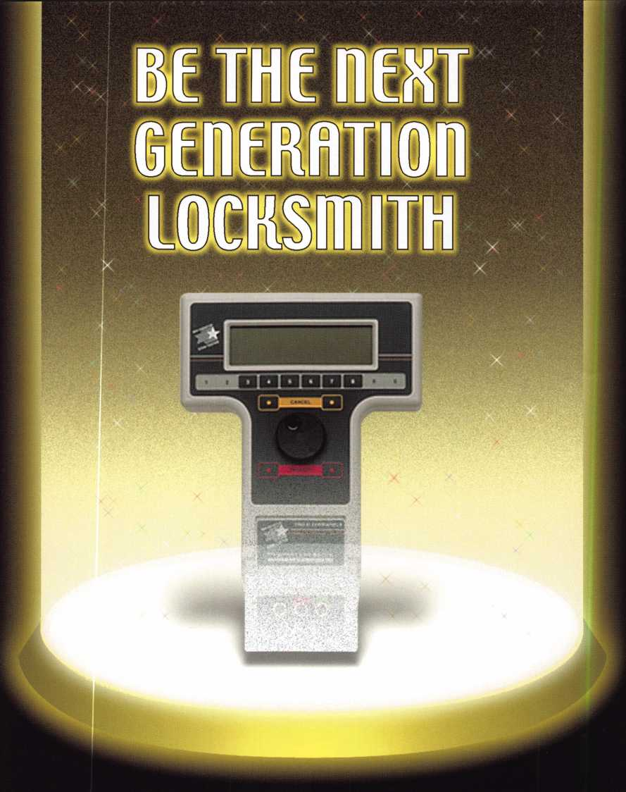

**Jump ahead of the competition  
at warp speed and see your profits soar.**

**Hickok’s New Generation STAR transports you with its advanced programming  
for keys to Ford-Lincoln-Mercury vehicles with passive antitheft systems.**

**Program vehicle keys through MY2000 with Hickok’s NGS Model 800-8LA—$1995**

HICKOK

INCORPORATED

phone 800/342-5080  
[www.hickok-inc.com](http://www.hickok-inc.com)

Heavy Metal.

Safe and vault technicians are not strangers to the concept of how to make large metal objects rock and roll. So what better place to hold the last safe and vault trade show of the millennium than The Steel City-Birmingham, Alabama?

From manufacturers' seminars, to education, to demonstrations and more, SAFETECH2000 is your best opportunity to prepare yourself for your future.

While you're there you can enjoy the city known for its industriousness, as well as good ol' South­ern hospitality. Tour the Sloss Furnaces, the Mercedes Benz factory or any of a number of museums. You can also explore the richly wooded foothills and mysterious caverns of the Appalachian Mountains.

Join us May 1 through 6 and we're sure you'll agree-Birmingham, and SAFETECH2000 rock!

For more information call

214.827.7233,

or visit our website at

[www.savta.org](http://www.savta.org)



**SAFETECH2000**WE'VE GOT THE WORKS



**March** 0o —

Features

4

President’s Journey

Revisiting the possible name change for ALOA.

15

Can Email Be Part of Your Marketing Strategy?

It’s becoming one of the fastest growing methods of communication. The question is, where does it fit in to your business?

By Claire Cohen, CML

Get Caught In the Net

about taking your business

retailing, its benefits and pitfalls.

By Paul Chandler, CRL

on-line?

Our author explores

Internet

Your Business

Expanding your business can be an intimidating task, be easier than you think.

By Claire Cohen, CML

Learn how it might

22

The Water Proof Trilogy from Alarm Lock

Part one in a look at one of the newest electronic keyless locksets.

By Sal Dulcamara, CML

28

Locksmiths Down Under

A visit to Australia leaves our author with insight into locksmith training across the globe.

By Michael Ferrill

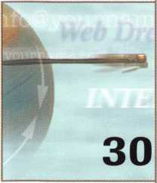

30

Web Dreams

A detailed look at the Internet and how you can start your own web site.

By Don B. Dennis, CPL

33

Legislative Update

Our legal eagle’s keeping busy. Learn about what’s happening on the  
legislative front.

By Tim McMullen

The Cover

This month, Keynotes explores the world, of computers & electronics.

Art direction/design Phoenix Concepts **972.479.9026**

ConQuest Graphixs **817.285.0003**

|  |  |
| --- | --- |
| | Keynotes | March 2000 |
| t |  |

Upcoming Events

Security Marketplace

Applicants for Membership

36

Classifieds

37

Ad Index

38

Associate Members

Volume 46, Issue 3

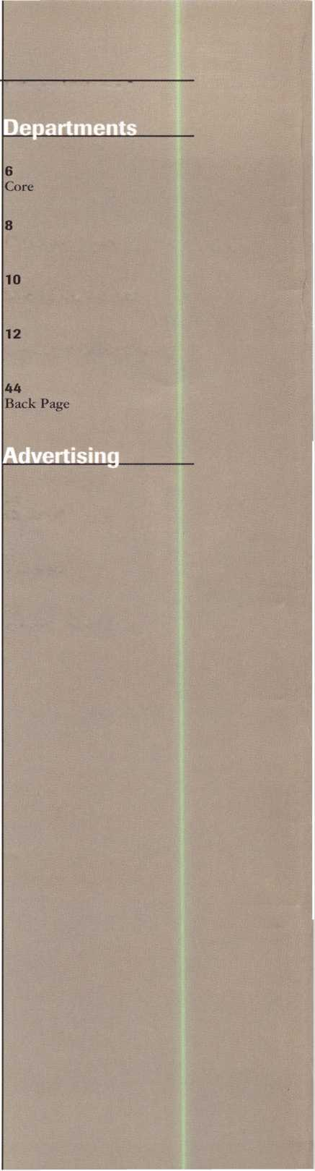

|  |  |
| --- | --- |
| Editor | Mike Emery [keynotes@anet-dfw.com](mailto:keynotes@anet-dfw.com) |
| Technical Editor | David Lowell, CML, CMS [david@aloa.ioffice.com](mailto:david@aloa.ioffice.com) |
| Communications/Financial Coordinator | Patanya Johnson |
| Editorial Advisor | John D. Cannon, CML [jdcannon@worldnet.att.net](mailto:jdcannon@worldnet.att.net) |
| Advertising Sales | Marvin Diamond  Native American Journal Co. (706) 782-0878 [thediamonds@mindspring.com](mailto:thediamonds@mindspring.com) |
| Contributing Editors | Paul Chandler, CRL  Claire Cohen, CML  Sal Dulcamaro, CML |
| Contributing Authors | Jerome V. Andrews, CML  Brian Costley, CML, CMS  Bob De Weese, CPL  Ray D’Adamo, CML  Michael A. Ferrill  James Glazier, CML  Daniel Graffeo, CRL, CMS Wayne Gurnee, CRL  A.J. Hoffman, CML  Ken Holmlund, CRL  Ray Lusk, CML  Mark Ohno  Randy Simpson, CML  Robert Stafford, CPL  Dave Thielen, CML |
| ALOA Professional Staff | |
| Executive Director | Charles W. Gibson, Jr., CAE [charlie@aloa.ioffice.com](mailto:charlie@aloa.ioffice.com) |
| Operations Manager | Mary May  [mary@aloa.ioffice.com](mailto:mary@aloa.ioffice.com) |
| Comptroller | Kathy J. Romo |
| Meetings Manager | Jessica Smith [jessica@aloa.ioffice.com](mailto:jessica@aloa.ioffice.com) |
| Government Affairs Manager | Tim McMullen [tim@aloa.ioffice.com](mailto:tim@aloa.ioffice.com) |
| PRP/Education Manager | David Lowell, CML, CMS david @aloa. ioffice .com |
| PRP/Education Coordinator | Ashley Spencer |
| Membership Coordinator | Shelly Jett |
| Chapters & Regional | |
| Associations Liaison | Tim McMullen  [tim@aloa.ioffice.com](mailto:tim@aloa.ioffice.com) |
| Information Systems Manager | Randy McChristian |
| Receptionist | Barbara Ortiz |

Executive

Additional contact information for the ALOA Board and most Keynotes authors is available through “Locksmith Search”’ on the ALOA website- [www.aloa.org](http://www.aloa.org) or by contacting the ALOA office at 3003 Live Oak Street; Dallas, TX 75204; 0800)532-2562;

FAX (214)827-1810; e-mail [aloa@aloa.org](mailto:aloa@aloa.org).



Mission Statement: The Associated Locksmiths of America, Inc. is dedicated to enhancing the professionalism, education and ethics among locksmiths and those in related sectors of the physical security industry. With approximately 10,000 members in the United States, Canada and the freeworld, ALOA is poised to help members obtain the knowledge, the strength, and the confidence to perform their role in the physical security field with pride and dignity. But it is only through active involvement and participation that ALOA can fully achieve its potential-and can help members to achieve theirs.

Policies: Keynoted is the official publication of the Associated Locksmiths of America, Inc. (ALOA). Keynoted acts as a moderator without approving, disapproving, or guaranteeing the validity or accuracy of any data, claim, or opinion appearing under a byline or obtained or quoted from an acknowledged source. The opinions expressed by the authors do not necessarily reflect the official views of ALOA. Also, appearance of advertisements and new products or service information does not constitute an endorsement of products or services featured by the Association. The Association does not accept responsibility for the inaccuracy of any data, claim, or opinion appearing in this publication, due to typographical errors on the part of the authors, Association staff or its agents. Editor’s Note: This publication is designed to provide accurate and authoritative information in regard to the subject matter covered. It is provided and disseminated with the understanding that the publisher is not engaged in rendering legal or other professional services. If legal advice and other expert assistance is required, the services of a competent professional should be sought.

Authors’ Payment: Payment for eligible submissions to Keynotes will be based on the following criteria: topic, time spent and past contributions. Authors who regularly submit to Keynotes are generally paid a higher rate. The latter is especially true of authors who write to fit specific editorial needs and submit said copy by Keynotes deadlines. As a general guideline: Average payment for a 750 word, business or ‘light’ technical article would be $200. Payment for a 1500 word article involving significantly higher time and research efforts would be $400.

Payment will not be offered for articles submitted by ALOA employees or members of the ALOA Board of Directors (unless material is of a technical nature], nor for articles submitted by a company that promote that company’s products or services. ALOA reserves the right not to pay for articles submitted by an individuals] that promote a particular company’s products or services.

Disclaimer: The Associated Locksmiths of America, Inc., (ALOA], reserves the right to refuse any article for any reason. Additionally, ALOA reserves the right to edit, amend or modify any article submitted for publication in order to preserve technical accuracy, clarity, fairness or grammatical correctness. ALOA will make the best efforts to notify the author of any changes. The extent of ALOA’s liability for any article or information contained therein will be a notice of correction or retraction in the next possible issue.

Keynoted (ISSN 0277 0792] is published monthly except for the combined June/July issue by The Associated Locksmiths of America, Inc., 3003 Live Oak St., Dallas, TX 75204-6186. Telephone: (214] 827-1701; FAX (214] 827-1810; e-mail [aloa@aloa.org](mailto:aloa@aloa.org). Subscription rates for members-$15.00 per year. Second class postage paid at Dallas, Texas. POSTMASTER: Send address changes to: Keynotes, 3003 Live Oak St., Dallas, TX 75204-6186. © Copyright 1999, All rights reserved. No part of the contents may be reproduced or reprinted in any form without prior written permission of the publisher.

Boaul



President

John J. Greenan, CML, CPS (773] 486-2030

Secretary

John D. Cannon, CML (703] 960-6413

Directors, Northeast

James H. Glazier, CML (301] 831-5454 John C. Magee, III

1. 845-3434 William L. Young, CML
2. ) 647-5042

Directors, Southeast

Thomas W. Tate (850) 476-4211 Donald E. Rule, CML (601) 324-2658

Directors, North Central

MarkE. Blum, CML, CPS (517) 482-5809 Tom Ripp, CRL (608) 262-3831

Director, South Central

Randy L. Simpson, CML (713) 780-7026

Directors, Southwest

Gordon R. Racine, CML (719) 384-4707 John A. Ilk, CRL (602) 420-2174

Director, Northwest

Scott L. Henke, CRL, CPS (907) 248-3785

Director, Associate Members

Judd Penske (800) 634-5465

Trustees

Dallas Brooks

(334) 826-8990

David M. Lowell, CML, CMS

(800) 532-2562

Breck H. Camp, CML

(770) 455-6244

Edwin Toepfer, RL

(416) 225-5589

Chairmen of International Affairs

Laurence P. Mills/Australia (129) 958-0445 Hans Mejlshede, CML/Europe FAX (453) 139-1004

Past Presidents

1997-1999 Dallas C. Brooks 1995-1997 David Lowell, CML, CMS 1993-1995 Breck Camp, CML 1991-1993 Henry Printz, CML 1989-1991 Evelyn Wersonick, CML, CPS 1987-1989 Leonard Passarello, CPL 1985-1987 Joe Jackman, CML 1983-1985 Stanley Haney, CPL 1981-1983 Louis LaGreco, CPL 1979-1981 John Kerr, RL 1977-1979 Clifford Cox, CML 1974-1977 Charles Hetherington 1972-1974 Gene Laughridge 1970-1972 William Dutcher, RL 1968-1970 Constant Maffrey, RL 1966-1968 Harold Edelstein, RL 1964-1966 William Meacham 1962-1964 Robert Rackliffe, CPL 1960-1962 Edwin Toepfer, RL 1956-1960 Ernest Johannesen

March 2000

Keynotes

with John J. Greenan

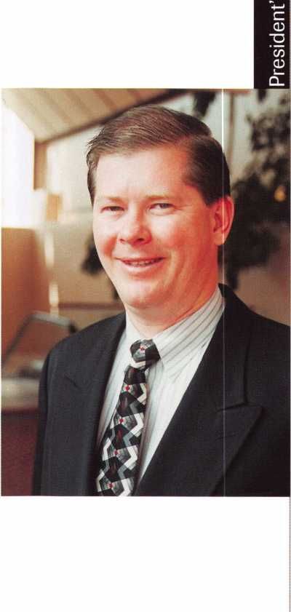

About two months ago, I used this column to propose the idea  
of a name change for our association.

In case you missed that particular issue (January ‘00), I pointed  
out numerous reasons why we should consider changing ALOA’s  
name. One reason is that our international numbers are increasing.  
We have chapters in places like Japan, Korea and Europe. We  
also have many members spread across the globe. From Mexico to  
Canada to England to Latvia and beyond, ALOA has truly become  
a global organization.

I also made mention how our industry extends beyond  
locksmithing. Sure, many of our members are bonafide locksmiths  
but ALOA also consists of alarm experts, safe technicians and other  
types of security professionals.

Unfortunately, I was unable to gain an adequate response to this idea.  
In fact, I hardly received any feedback at all.

This is surprising considering how a name change could affect  
our association in numerous ways. Our visibility could increase as  
well as our membership numbers.

This is a vital subject and one that can benefit the growth  
of ALOA. Of course, many might oppose a name change. Others  
my support such a notion. Whatever the case, the decision  
should be YOURS.

This is your association. You should have the ultimate say  
about its direction and its future. With that, I am again asking  
for your response.

I can be reached at (773) 486-2030, (773) 486-4268 fax or  
[fsl.john@mindspring.com](mailto:fsl.john@mindspring.com).

I look forward to your comments and questions.

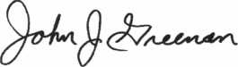

John J. Greenan, CML, CPS

Keynotes

March 2000

.William Grant, CRL _Gary Teams, CPL _William McElheney, CML

Robert Duman, CML

Russell Fuller, CRL

Rex Parmelee, RL

James Gruber, CRL

James Brickler, CRL

Michael Groves

Daniel Landry

Edwin W Scott

_Peter Gauthier, CPL _Frank Hartung, CML

Jon Griswold, CML

Paul Souber

Richard Sievers

Joe Lee, CRL

Steven Spiwak, CRL

_Robert Rodocker, CRL _Keiryu Tsukishiro, CRL Rolando Bouza

_Lonnie McKinney, CML

John Engel, CRL

Donald Shiles

Eric Veal

_Herbert Dusenberry, CML

Raymond Lusk, CML

Dale Knowles, CPL

_Robin Horsley

.Thomas Demont, CML

_Ernest Wright

_William Wickward, CML

_Lester Brodsky

Joseph Whitaker, CPL

James Hawley, CRL

How can IjUt inSHfresraent's Club?

You can earn membership in this prestigious club by recruiting just 10 new members for ALOA.

*Any ALOA member may participate.

What do I get?

When you recruit 10 members, you receive a handsome blue blazer with a President's Club crest. For each additional five members you recruit, you receive a lapel pin with gold-filled numbers, indicating your recruiting successes.

You also get the satisfaction of knowing that you are helping your association, helping your industry grow, and you are helping fellow locksmiths achieve success.

How do I get started?

Contact the ALOA office for a supply of applications (800) 532-ALOA or FAX (214) 827-1810. One President's Club credit is awarded for each new applicant. Credit is awarded only after the membership application is approved. However, the credit will apply for the period in which the application is received. Failure to identify yourself as the sponsor on the application form at the time it is submitted to ALOA for processing will forfeit any credit.

*ALOA Board of Directors not eligible for membership in the President's Club.

Kwok-kei Leung

Toshihiro Asano

Henry Raymond

Stewart Levine, CML

.Charles Robertson, CML

Mary Ohmit, CPL

Yuriko Yanai

Jack Hobin, CPL

Allen Konrath

.Salvatore Dulcamaro, CML

Myeong-Rae Cho

.William Neff, CML

David Lowell, CML

.Thomas Freehling, CML

Dana Barnum, CML

John Heckman, CML

Jeanne Lodge, CML

Barry Leas, CRL

J Thomas Hood, CML

Danny Rudd, CPL

John Elliott, CML

Larry Warnick, CML

Roy Renderer, CML

Jim Williams, CRL

James Watt, CML

Robert Carroll, CPL

Robert DeWeese, CPL

Diana Barnum, CRL

.Anthony Ramunno, CML

Jerome Cohen, CML

David M A Federico

Eugene Altobella

William Lee

Charles Cole, CML

.Elvis Hammerschmidt, CPL

Marian Swann, CRL

John Shandy, CML

John Dorsey, CML

.James Fowler, CML

David Harris, CML

Keizo Takahashi, CRL

Ronald Heidzig

Philip Rovenolt, CPL

Lawrence Smith, CML

Joseph Ferrero, CML

James Cawby, CML

Michael Robinson, CRL

Brian Reetz

Walter Lascar, RL

.Thomas Vandersteen, CML

Best



core

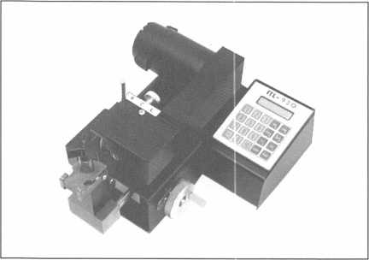

The ITL-950 key machine

* We’ve Got A Winner!

It’s true! Punctuality pays off! ALOA Members who paid their dues by January 1 were entered in a drawing for an ITL-950 key machine.

The lucky winner was Leonard Downing, CRL of Salem Ore. Congratulations, Leonard!

* Board Meeting This Month

The Spring Meeting of the ALOA Board is March 10-12 in Las Vegas, Nev. at the Las Vegas Hilton (also home to ALOA 2000). For further details, call the ALOA office at (800) 532-2562.

* A Little Press Can Go A Long Way

It just goes to show you that communication is the key to success. Take for instance, RlISS Rackliffe, CRL of Essex, CT. Just by making his local newspaper aware of his shops 25 th anniversary, he was able to get an article written about himself. Rackcliffe is a fifth generation locksmith, whose great uncle, Robert Rackliffe served as ALOA President from 1962-’64.

* Life’s a Super Bowi of Cherries

While St. Louis is still reveling in its first football championship and Tennessee is still in shock from their near comeback, Paul Caruso is probably also thinking about Super Bowl XXXIV. After all he was the grand prize winner of a contest sponsored by ADI and Sentrol. His name was drawn from 60,000 entries to win two tickets to the game, three night deluxe hotel accommodations and a rental car. 19 runners up also scored big with a catered Super Bowl party.

* ASIS Goes Back to School

This month, the American Society for Industrial Security (ASIS) is sponsoring a two-day program on issues pertaining to School Security Threats and Strategies. It will be held March 6-7 in Washington DC while another will be held in Chicago July 10-11. The seminars will provide updates on school security trends and issues, increase awareness on possible threats to security and explore the changing role of securing school environments. For more details about these programs, call ASIS Customer Service at (703) 519-6200.



Keynotes

March 2000

Wyoming celebrated its first Locksmith Day. ”

• Obituaries

* Regions

This past January, locksmiths in Wyoming had something to cheer about. January 18th, 2000 was the first-ever Wyoming Locksmith’s Day! The recognition comes in conjunction with the Wyoming Locksmith’s Association’s 25th anniversary. In his proclamtion of this great day Wyoming Governor, Jim Gerringer, recognized locksmiths as individuals who “use their technical knowledge in creative and innovative ways to fulfill an important consumer need for safety and security of life and valuables.”

The San Diego Locksmith Association (which is the combined local ALOA chapter and California Locksmiths Association) holds its meetings on the last Tuesday of every month. Meetings will feature educational programs and open discussions on tricks of the trade 6:30 pm to 9:00 pm at 1049 Island Avenue, San Diego, Calif. 92101. For more details, call (619)234-4829

The California Locksmith Association conducts its apprenticeship program on Thursday evenings, at 7:00 pm at Grah Safe and Lock at 1049 Island Ave., San Diego, Calif. 92101. Admission is free for CLA and ALOA members and their employees. For more information, call (619) 234-4829.

The California Locksmiths Association will also hold its biggest trade show ever April 15 at the Disneyland Hotel in Anaheim, Calif. Attendees who pre-register by April 5 will receive a raffle ticket for a $300.00 gift certificate to be used at the distributor of their choice at the show. For more details, call CLA at (714) 632-6809.

* Execs
* Olympus Lock is pleased to announce the addition of Jim Negri as General Sales Manager.
* The Greater Alarm Company (GAC) expanded its Northern California Sales and Marketing department with the addition of System Consultant Wendy Kreutzberg and Marketing Director Don Meadows.
* PRP

CRL

Gerald R. Hiebert, Vero Beach, FL

ALOA regrettably bids farewell to some wonderful friends and loyal members. Our hearts and prayers go out to the friends and families of the following individuals.

* Gilbert Erdman, 83, was a World War II veteran and had trained with the Mosler Safe Company before starting the Howard Safe Company in 1949- He was a founding member of the Michigan Master Locksmiths Association and a member of ALOA. He has the distinction of building the first “truck safe” in mass production for commercial trucks in Detroit.
* Sabra Barnhardt, the wife of ALOA member James Barnhardt (President of Economy Lock and Key of Brandon in Lakeview, Fla.)

**TURPI lO**

800**-**848-9790

One Call  
Gets You...

Amsec

•

Gardall

•

Hayman

Mei'link

Victor

•

Winchester

Plus Free Delivery  
From America's  
Largest Inventory  
of Safes.

CPS

Glenn Ross, Lubbock, TX

March 2000

Keynotes

Upcoming

Events



Deptl

MARCH

10

^ALOAPRP Sitting Dallas, TX

Contact: Ashley Spencer (214) 827-1701 (214) 827-1810 fax

10-12

ALOA Board Meeting Las Vegas, NV (800) 532-2562

11-12

OPLA Annual Retreat Eureka Springs, AR

Ozark Professional Locksmith Association Contact: Betty Gray (501) 524-3660 Bill or Janis Reves (501) 631-0017

12

^ALOAPRP Sitting Rosemont, IL Clark Security Products Contact: Ron Cooling (858) 974-5273 (858) 974-5284

1. 16

SiteLine Certification Biaxial Certification KeyMark Certification Salem, VA Medeco

Contact: Lisa Burton (540) 380-1826

1. 16

ISC Expo Las Vegas, NV (800) 840-5602 isc.reedexpo.com

1. 19

IDN Trade Show & Security Conference jJ^PRP Sitting Troy, MI

IDN Hardware Sales, Inc.

Contact: Fred Strasberger or Bonnie Weston (800)521-0955

18

Georgia Chapter Monthly Meeting Atlanta, GA

Georgia Chapter of ALOA IDN Armstong 9 am Contact: Steve Gebbia, CML (770)455-6242

1. 19

Buyers Trade Show & Classes St. Petersburg, FL Southern Lock & Supply Co.

(800) 282-2837 [www.southernlock.com](http://www.southernlock.com)

19

^ ALOA PRP Sitting Lancaster, PA

Neffs Safe Lock & Security Inc Contact: William Boyd Neff, CML (717)581-8303 (715) 626-8598 fax

24-26

Spring Education Classes ^ ALOA PRP Sitting Holiday Inn, Hattiesburg, MS Lou-Miss Locksmith Asscoc.

Contact: John Kick, CML (601) 649-5426

APRIL

2

jk ALOA PRP Sitting Oakland, CA Clark Security Products Contact: Ron Cooling (858) 974-5273 (858) 974-5284 fax

2

fk ALOA PRP Sitting Poison, MT

Montana Chapter of ALOA Contact: Renae Rasmussen (406) 883-2950 (406)883-4518

1. 9

MLANJ Annual Convention Yr Ace Classes Somerset, NJ

Master Locksmith Association of New Jersey (973) 267-8884 (973) 538-2248 fax [www.mlanj.org](http://www.mlanj.org)

8

j^ALOA PRP Sitting White Bear Lake, MN Minnisota Chapter of ALOA Contact: Nathan Andrews (612) 823-8148 (612) 822-7716

Indicates ALOA ACE Class Indicates PRP Sitting

14

^ ALOA PRP Sitting Dallas, TX

Contact: Ashley Spencer (214)827-1701

1. 827-1810 fax

14-16

Trade Show & Education Fargo, ND

Northern Prairie Chapter of ALOA Contact: Todd Or James Ladwig (701) 232-9440

15

California Locksmith Association Trade Show

Anaheim, CA

Contact:

Dan Enriquez (800) 964-0700 or Kelley Ramirez (800) 767-5625

1. 23

Easter Convention Birmingham, England Master Locksmiths Assoc in the UK Contact: Mick Friend [mick@locksmiths.co.uk](mailto:mick@locksmiths.co.uk)

26-29

Security Hardware Distributors Association (SHDA)

Conference

Jacksonville, FL

1. 564-3484 [www.shda.org](http://www.shda.org)

28-30

Annual Convention & Trade Show Casper, WY

Wyoming Locksmiths Association Contact: Gene Ficek, CPL (605) 642-4542

MAY

1-6

SAFETECH 2000 jk STPRP/PRP Sitting Birmingham, AL Contact: Ashley Spencer (214)827-7233

9-10

ISC Expo Miami, FL (800) 840-5602 isc.reedexpo.com

***Keynotes***

March 2000

12

/ ALOA PRP Sitting Dallas, TX

Contact: Ashley Spencer (214) 827-1701 (214) 827-1810 fax

12-14

North Carolina Quarterly Meeting Raleigh, NC

North Carolina Locksmith’s Association (910) 980-0901

17-20

ELF Convention Sofia, Bulgaria [www.bcci.bg/-clients/alob](http://www.bcci.bg/-clients/alob)

20

Annual General Meeting of Japan Chapter Jal City, Nagasaki Japan Japan Chapter of ALOA Contact: Keizo Takahashi

81-45-582-4469

JUNE

9

/ ALOA PRP Sitting Dallas, TX

Contact: Ashley Spencer (214)827-1701 (214)827-1810 fax

9-10

iT\ Ace Classes Albuquerque, NM NMLA

Contact: Steve Smith (505)681-6777

11

/ ALOA PRP/STPRP Sitting Albuquerque, NM NMLA

Contact: Steve Smith (505)681-6777

21-22

ISC Expo Chicago, IL (800) 840-5602 isc.reedexpo.com

JULY

14

/ ALOA PRP Sitting Dallas, TX

Contact: Ashley Spencer (214) 827-1701 (214) 827-1810 fax

24-30

ALOA 2000 Security Expo Ace Classes Las Vegas, NV Contact: Ashley Spencer (214)827-1701

28-29

/ PRP/STPRP Sitting Las Vegas, NV Contact: Ashley Spencer (214)827-1701

AUGUST

ii

/ALOA PRP Sitting Dallas, TX

Contact: Ashley Spencer (214) 827-1701 (214) 827-1810 fax

20

/ALOA PRP Sitting Ellicott, MD Clark Security Products Contact: Ron Cooling (858)974-5273 (858)974-5284 fax

28-31

ISC Expo New York, NY (800) 840-5602 isc.reedexpo.com

SEPTEMBER

1. 9

DHI Convention San Francisco, CA Contact: Kathy Devey (703) 222-2010

8

/ALOA PRP Sitting Dallas, TX

Contact: Ashley Spencer (214)827-1701 (214)827-1810 fax

1. 10

TAOL 27th Annual Convention Toronto, ON Canada Contact: DonDeKuyper (416) 321-2219 (888) 272-8265

11-14

ASIS Convention Orlando, FL (703) 522-5800 [www.asisonline.org](http://www.asisonline.org)

17

/ALOA PRP Sitting Buena Park, CA Clark Security Products Contact: Ron Cooling (858)974-5273 (858)974-5284 fax

1. 24

GPLA 50+1 Convention Philadelphia, PA Contact: Nelson Dayton (610) 688-9188 [www.gpla.org](http://www.gpla.org)

24

/ALOA PRP Sitting Philadelphia, PA Contact: Nelson Dayton (610) 688-9188 [www.gpla.org](http://www.gpla.org)

OCTOBER

13

/ALOA PRP Sitting Dallas, TX

Contact: Ashley Spencer (214)827-1701 (214)827-1810 fax

13-15

SERLAC Cr\ Ace Classes Jacksonville, FL Contact: James Riley (941) 294-8679

23-27

Tri-Regional Show Seattle, WA

Contact: Robert Kotovic (847) 692-5940

NOVEMBER

6-10

Yankee Security Conference Sturbridge, MA (800) 209-8266

10

/ ALOA PRP Sitting Dallas, TX

Contact: Ashley Spencer (214) 827-1701 (214) 827-1810 fax

DECEMBER

8

/ALOA PRP Sitting Dallas, TX

Contact: Ashley Spencer (214)827-1701 (214) 827-1810 fax

2001

MARCH

28-April 1

MLANJ 2001 Annual Convention Somerset, NJ (973) 267-8884 (973) 538-2248 fax [www.mlanj.org](http://www.mlanj.org)

JULY

16-22

ALOA 2001 Security Expo Baltimore, MD (800) 532-2562

2002

JULY

22-28

ALOA 2002 Security Expo Rosemont, IL (800) 532-256

March 2000

***Keynotes***



Security

Marketplace

Frank J. Martin Company

The Frank J. Martin Company recently announced its patented Shurlock product. The Shurlock Security Lock Box is all metal and has 10,000 possible combinations. One combination opens the compartment where items are stored. Another opens the shackle. With an accessory bracket, Shurlock can be mounted anywhere. Among the applications for this product are access to commercial and construction site; real estate security; after school access for children; access for maintenance workers.

Frank J. Martin Company 8512 20th Avenue Northeast Seattle, WA 98115 (206) 523-7665 (206) 523-9876fax

Security Door Controls

The new SDC 602RF modular power supply is designed for use with access controls and electric locking hardware. UL Listings include Access Control Systems Unit, Fire and Burglary Alarm Power supply and releasing device accessory. Features include 1 Amp Output, field delectable 12/24/VDU, for emergency release input, choice of 10 relay modules, battery charger and low battery disconnect. The specified secondary output is maintained while charging.

Security Door Controls

3580 Willow Lane

Westlake Village, CA 91361-4921

(805) 494-0622

(805) 494-8861 fax

Zero International

Zero Internationals 2000 Catalog features new products, listings and applications. Among the items available are an intumes- cent kerf wood frame system and additional door constructions with Zero’s 20 minute license for full-assembly compliance with the UBC 7-2 1997 Fire Door Standard. Also listed is Zero’s model #770 acoustical door seal with a cased-opening fire rating that allows use with any door and hardware appli­cations up to 90 minutes. The catalog also



provides specification guidance and full-size schematics for hundreds of components and integrated systems for blocking air, light, sound as well as flames and smoke. New for 2000 is Zero’s BRASSART line of solid- brass, decorative hardware.

Zero International, Inc.

413 Concord Avenue Bronx, NY 10455-4801 (718) 585-3230 (800) 635-5335 (718) 292-2243 fax

Gradient Lens Corporation

Quality control inspectors, technicians and maintenance crews who use borescopes don’t always have comfortable headroom for inspections. A new borescope accessory from Gradient Lens Corporation can be an economical solution. The accessory clamps onto the borescope eyecup and reflect the image in sharp detail. The Hawkeye Angles Eyepiece AE 9003 works with any rigid or flexible borescope with a standard DIN eyecup. It fits all Hawkeye borescopes made my Gradient Lens as well as those made by Karl Storz GmbH & Co. of Germany, which are distributed by Gradient Lens. It is also compatible from nearly every other manufac­turer. The accessory is a cost-efficient solution to the problem of using a borescope in tight or awkward spaces for quality control inspectors in machining and manufacturing, maintenance crews who inspect aircraft, diesel or automotive engines, safe and vault inspectors, gunsmiths and precision shooters and pest control technicians.

Gradient Lens Corporation 207 Fremont St.

Rochester, NY 14608 (716) 235-2620 (716)235-6645 fax wunv.gradientlens.com [info@gradientlens.com](mailto:info@gradientlens.com)

Trine Products Company

Trine Products Company recently issued an informative booklet and poster on EN Fire Rated strikes and accessories. The brochure contains photos and relevant data

on all EN Strikes. It also includes a cross reference chart and information on Trine’s new EN-LB Sensor, the optical IR accessory that confirms positive latching of a lockset within an EN Strike. The 26” x 32” poster can be mounted in a warehouse or showroom where it can be referred for detailed informa­tion. It contains descriptions, templates, compatible lockset data and additional infor­mation to determine the specific strikes suitable for certain applications.

Trine Products Company 1430 Ferris Place Bronx, NY 10461-3699 (718) 829-2332 (718) 829-6405 fax

Jet Hardware

Jet Hardware recently announced their ETD-l-JR affordable alternative model of the electronic Transponder and duplicator. It is designed for duplication only and cannot be linked to a PC for storage. The ETD-l-JR will clone all programmable Transponder keys and includes both AC adapter and a 9- volt battery pack. The H86-PHT Transponder key to fit the new Ford Focus is now available.

Jet hardware 800 Hinsdale St.

Brooklyn, NY 11207

Sargent and Greenleaf, Inc.

Sargent and Greenleaf has freshened the face of an industry standard with the intro­duction of new dial inserts. The inserts offer a new look for the 21st century. Simpler in design, the inserts feature a cleaner, richer look, with gold lettering on black and a distinctive silver line around the edge. The new dial inserts will become the standard for both key locking and non-key locking convertible dials.

Sargent and Greenleaf, Inc.

PO Box 930

Nicholasville, KY 40340-0930 (606)885-9411

(606) 887-5226fax

***Keynotes***

March 2000

Marks USA

Marks USA will provide free on-request, a Facilities Lockset Guide introducing the “Survivor” key-in lever series, “Defender” deadbolt series and “Protector” mortise lock series. The guide assists the institutional user by informing the reader of lockset features, which will satisfy the requirements of institutional facilities for both design and maintenance. A1 locksets feature a lifetime, mechanical warranty, satisfy ADA require­ments and UL Listed for 3-hour fire rating. Typical users of these locksets include school systems, housing authorities, hospitals, Army Corp of Engineers and the United Nations.

Marks USA

5300 New Horizons Blvd.

Amityville, NY 11701 (631) 225-5400 (631) 225-6136fax nancy @ marksusa.com

Ingersoll-Rand Architectural Hard­ware

A new eight-page color catalog describes the Von Durpin e.primus Access Control System, which is designed to operate hardwired door hardware such as electrified panic or fire exit hardware, electric strike, electromagnetic locks and other electrified locks. The Von Duprin system is fully compatible with all Schlage e.Primus Electronic Key Control Systems. Its standard features now include a comprehen­sive range of functions. The catalog explains the systems features and time functions. Using new time functions, specific activation times can be assigned to user keys to allow entry only during certain periods. Plus, expiration dates and times can be assigned to a key. Locks operation can be set up to unlock and relock automatically at specific times and days, and a “privileged” key allows authorized personnel to override this function. Ten user-selected holiday periods are available as well. Other features include a lock-down key for emergency operations, rapid success authorization changes, audit trails and multiple touring and database capabilities that increase user flexibility.

Ingersoll-Rand Architectural Hardware

Von Durpin Division

2720 Tobey Drive

Indianapolis, IN 46219

(317) 897-9944

(317) 899-9302 fax

Sieveking Products Co.

Sieveking Products Co., announced the addition of the “Key-Scope” to its growing line of locksmith tools. This wafer lock reading tool incorporates features not found in any other scope. Key-Scope has a new variable intensity high output light. The longer wafer depressor allows the locksmith to read wafers in deeper keyways. There are two viewing lenses on Key-Scope. One lens is short focus, for standard keyways, the other is long focus for deeper keyways and safe work. Used together, the Key-Scope lenses ADD, to give a higher magnification, ideal for reading those hard to see impression marks. A padded hard-shell is included. Sieveking also announced changes to the Squeeze-Play hollow metal door mortising tool. The tool will mortise 90- percent of the edge seamed hollow metal doors found in residential and commercial markets. Improvements made to the automatic center punch feature will increase the depth of the punch marking. Squeeze- Play automatically locates and punches the locations of the square face bolt mounting screws. Squeeze-play will mortise 1 3/4” doors, and mark mounting locations for 2 1/4” x 1” and 2 1/4” x 1 1/8” square face bolts, eliminating the need to cut the door or use internal bridges. The mortise is made with no loss of the doors structural integrity. Sieveking Product Co.

3437 South Bend Road Rockford, IL 61109 (815) 874-4030

SECURITyiS

LOCK COMPANYBV

**New** Factory Replacement Parts and Locks for Security Corporation and Kumahira Safe Co. Products

* Safe Deposit Box Locks and Parts BX, KD
* Automatic Remote Tube Systems (ARTS)
* Drive Up Systems
* Vault Doors
* Night Depositories
* Camera Systems
* Key Blanks and
* Keys Cut to Code

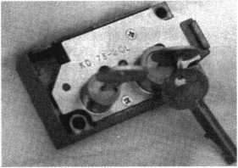

KD Series

Safe Deposit Box Locks

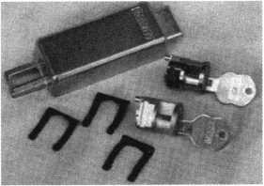

BX Series Safe Deposit Locks

1155 Chess Drive, #114 Foster City, CA 94404 Phone: (650) 525-0660 Fax: (650) 525-0444

Email:

[chaslutz@securitylockco.com](mailto:chaslutz@securitylockco.com)

SECURITyiB

LOCK COMPANY

March 2000 Keynotes

Applicants

For Membership

Dept

***The following applicants are scheduled for clearance as members of ALOA The names are published for member review and comment prior to April 1, 1999, respectively, to ensure applicants meet standards of ALOA's Code of Ethics. Protests, if any, should be addressed to the Membership Department and must be signed. Active Membership applicants [A] have worked in the industry two or more years. Allied Membership (AL) applicants are not locksmiths, but work in a security-related field. Apprentice Membership (AP) applicants have worked in the industry less than two years. A***

|  |  |  |  |
| --- | --- | --- | --- |
| ALABAMA | LOUS IAN A | NEW MEXICO | CANADA |
| Auburn University | Alexandria | Albuquerque | BC |
| Charles V Wood | John A Morovich | John C DeMoss | Youbou |
| Birmingham | MASSACHUSETTS | Benjamin Mooney | James F Brouchton |
| Wayne Panned | Arlington | Leslie Wise | JAPAN |
| ARIZONA | John F O’Connell | NEVADA | Kitakyushu-city |
| Glendale | Spencer | Las Vegas | Ryosuke Tasaka |
| David J Louie | Paul J Kaminski | John E Spence | GERMANY |
| CALIFORNIA | MARYLAND | NEW YORK | Frankfurt |
| Bakersfield | Bowie | Fort Edward | Igor Matanovic |
| Floyd D Bagley | John A Speakes | Charles D Ward | HONG KONG |
| Healdsburg | Catonsville | Summit | Hong Kong |
| Eric A Ziedrick | Paul Freuwdel | Wayne A Stinson | Yip Kin |
| San Juan Capistrano | Hyattsville | Syracuse | KOREA |
| Lawrence H Barney | Carlton L Scott | Marc C Gladziszewski | Ulsan City |
| Santa Ana | Silver Spring | OHIO | Jae Ki Lee |
| Walter J Richardson | Ary T McPhail | Cincinnati | Nam-Gu |
| COLORADO | MAINE | Gary Griffith | SunTaek Kim |
| Louisville | Wells | Columbus | Sahagu |
| Edmond J Crowley | Stevens Van Voorhies | Mark Werner | Young-Ho Yang |
| Northglenn | MICHIGAN | OKLAHOMA | Kangnam-Gu |
| John T Cleveland | Brighton | Oklahoma City | Jae-Hee Lee |
| CONNECTICUT  New Britain | Ray S Barnes | Matthew S Kelm | Nam-gu  Youm Soo Kim |
| Redford | PENNSYLVANIA |
| Gerry H Reny | Thomas P Anderson | Camp Hill | KOREA |
| Orange | MINNESOTA | Shelby Liddick | Bundang-gu |
| Sheldon H Krasnow | Duluth | Jayson A Beers | Hyunjoo Kim |
| FLORIDA | John D Phillips | Glenside | JAPAN |
| Jupiter | MISSOURI | Jesse C Oberman | Asaka City |
| David W Logan | Lees Summit | Harrisburg | Tomoyuki Kumagai |
| Orlando | Bob G Turner | Brenden T Orth | Japan Kawaguchi-city |
| Dan Watts | MISSISSIPPI | TEXAS | Teruo Ogasawara |
| GEORGIA  Atlanta | Biloxi  James F Weaver | Forney  David M Hetherington Jr | Japan Bunkyo-ku  Akihiko Isoda |
| Donald E Hill  Robbie A Balenger Jr | Gautier  Ronald G Ferrill | Fulton  Ruth E Davis | ltabashi-ku  Tatsuya Sezaki |
| IDAHO  Lewiston | Hattiesburg  Keven S Broome | Houston  William T Waterhouse | SINGAPORE  Francis Lum |
| Bretton S Watson | NORTH CAROLINA | Lubbock |  |
| ILLLINOIS | Monroe | Kenneth G Lundgren |  |
| Chicago  Carlos U Lopez | Javonnie L Wilkins  NEBRASKA | Plano  Charles A Brasier |  |
| Daniel R Cermak | North Platte | San Benito  Robinson M Crusoe |  |
| Urbana | Nathan R Heessel |  |
| Jason D Brandon | NEW JERSEY | VIRGINIA |  |
| INDIANA | Linden | Salem  Roscoe H McFadden |  |
| Indianapolis | John Turczmanovicz Jr |  |
| Willie Strong  KENTUCKY | Toms River  Joseph A Senica Jr | Virginia Beach  David A Ibrig |  |
| Winchester | Union | WASHINGTON |  |
| Frank Cornmesser | Perry W Zranchev | Seattle  Robert A Davis |  |

***Keynotes***

March 2000



“If you want to study for the CPS test,

you need this book.

Without that book, I wouldn’t have my certification.”

-Dennis Johnson, CPS  
Aurora, Illinois

"Mike's new book is very  
consistent with the study  
information required to pass the  
SAVTA/ALOA CPS certification  
test. I wouldn't have passed  
without it. *A tremendous  
resource for today  
and tomorrow..."*

-John T. Grist, CML, CPS  
North Georgia Security

"The Safe Technicians Reference Manual by Mike Oehlert ranks among the best technical reference and learning aids you will find in the safe and vault industry. It contains page after page of essential information and easily understood illustrations. Besides answering most of the questions commonly asked by technicians new to the field, Mike has also included plenty of information experienced technicians will find useful."

-Ken Dunckel Pacifica, California

—►Over **600** Illustrations.-*—

320 **pages.** Only $135.

What are you waiting for?

To order, call 800-532-2562. Allow 3 weeks for delivery.

All major credit cards accepted; or make check payable to ALOA.

The Safe

Technicians  
Reference Manual

First Edition

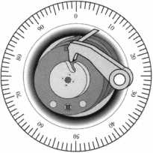

The **2000** edition of Steve Young’s Quick Entry Car Opening Manual

is now available!

If you’ve been looking for an ACCURATE and easy to use car opening manual, your search is over. Steve Young has personally disassembled hundreds of door panels to guarantee you that each opening method is the easiest and safest way to open the car. You can be sure that the methods shown in this manual will work!

If you have ever met Steve Young, then you know why he is often referred to as “The world’s leading authority on car opening.” Steve Young has built a reputation for providing accurate and reliable car opening information. The attention to detail in this manual continues that tradition.

You won’t find any catalog reprints, endless duplicate pages or advertising in our manual! That’s why we can give you all of the information you need in one volume while others want you to buy two or more volumes! Instead of wasting your money on fuzzy, hard to understand photos, the Quick Entry Manual features clear, concise line drawings of each car door to show you where the linkages

VEHICLE: CADILLAC SEDAN DEVILLE (DTS), 2000 WEDGES: YES LIGHT: OPTIONAL TOOL: TT-1001

DIRECTION OF TURN: CLOCKWISE*

This vehicle is equipped with seatback-mounted side-impact airbags for  
both front and rear seat passengers as standard equipment. Because the airbags  
are mounted in the seatbacks there is no risk of damaging the airbag with car  
opening tools. The vehicle can be unlocked easily through the REAR DOOR.

Begin by wedging open a gap at the base of the main window of the  
REAR DOOR as far to the rear as possible. Before inserting the tool into the  
door, compare the length of the tool to the position of the outside door handle,  
so that you can tell when the end of the tool is at the same level as the handle.  
Insert the tool into the door, as far to the rear as possible, and then lower it until  
the tip is at least as deep as the outside door handle. Rotate the tool so the  
hook is pointed toward the inside of the car and then pull up on the tool. The tool  
should now be hooked around the inside lock control linkage rod. Twist the  
handle of the tool in order to bind the linkage, then lever the linkage rod forward  
to unlock the door. If you have trouble locating the linkage rod, an inspection

light can be inserted into the door and the linkage rod can be located visually.

'Direction of turn for driver side only. Passenger side has no loslccyltncISn

Page: USA 149

“I personally

guarantee

your complete  
satisfaction or your  
money back! ”

Steve Young, Owner  
Tech-Train Productions

and guards are located. You also get a step-by-step  
explanation of how to open each car, plus the direction  
of turn to pick the door lock. Alternate methods are  
included for hundreds of vehicles so that you’re not  
limited to one method or tool. Warnings are printed in  
bold print to alert you to potential problems with  
particular vehicles. This manual makes car opening easy  
for both beginning and experienced locksmiths!

The Quick Entry Manual

is the perfect companion for

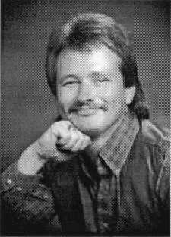

EASY TO UNDERSTAND  
“CUT-AWAY” STYLE  
DRAWINGS SHOW YOU  
WHAT’S INSIDE EACH  
DOOR!

EXCLUSIVE TECH-TRAIN  
DIFFICULTY INDEX TELLS

YOU HOW EASY EACH  
VEHICLE IS TO OPEN!

QUICK-REFERENCE

HEADING FOR EACH CAR  
QUICKLY GIVES YOU THE  
IMPORTANT INFORMATION  
YOU NEED TO  
UNLOCK THE CAR!

EACH VEHICLE IS EASY  
TO FIND WITH OUR  
ALPHABETIZED INDEX OF  
OVER 500 DIFFERENT  
VEHICLES BY MAKE AND  
MODEL YEAR!

your Tech-Train tool set, but this is one manual that can be used with anyone s tools. Because the Quick Entry Manual shows you where the linkages and guards are located, you can use other tools that you already own!

The 2000 Quick Entry Manual and manual updates are available directly from Tech-Train and Security Resources, Inc. Order your Quick Entry Manual risk free today for only $89.95 plus $7.00 shipping and handling. Owners of our 1999 manual should call (800) 356-0136 for a special offer and to order their 2000 update as soon as possible.

We guarantee complete satisfaction or your money back. Wouldn’t you like to own the most complete and accurate car opening manual in the world?

ORDERRISK-  
YOURS for  
TODAY! only.

Call (800) 356-0136 today

for our FREE catalog!

PRODUCTIONS  
P.O. BOX 15401

PENSACOLA, FL 32514

«L

Keynotes

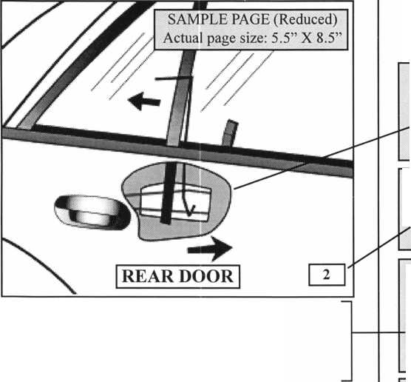

**Can E-mail Be Part of Your Marketing Strategy?**

**By: Claire L Cohen, CML**

E-mail (electronic mail) is the technology of sending and receiving electronic messages over phone lines by computer. The technology surrounding E-mail is advancing rapidly.

If you have Internet access, you have E-mail capability.

A growing number of individuals and companies are discovering the advantages of E-mail as more and more businesses are getting connected to the Internet. So, what marketing benefits can E-mail bring to your locksmith/ security business?

**FAST!**

E-mail is far quicker than U.S. Mail. Nicknamed “Snail Mail", it may take U.S. Mail from a day to a week or more for delivery. If you have a hot prospect, it is to your benefit to deliver information on your products and services IMMEDIATELY. Each day lost waiting for information tends to dampen enthusiasm. Customers want information NOW!

E-mail lets you communicate instantaneously with anyone who has a computer and modem and E-mail, usually within seconds or minutes. This means you can get your ideas, product literature and/or prices to your prospects while their interest is high. Depending on the sophistication of your customer/potential customer s E-mail sen ice, you may not always be able to send attachments (scanned images, price lists, letters, etc.) via E-mail. Anyone with Internet access, however, can at least send and receive basic text messages. Depending on the ty pe of sy stem you and your recipients use, you can send enhanced text (your logo, special fonts, boldface, underline, etc.,), word processing documents, spreadsheets, scanned images (diagrams, instruction sheets, sell sheets, sale fliers), and even audio and video Hies.

**RELIABLE!**

Occasionally, regular mail gets lost, or misdelivered. Within seconds. E-mail reliably makes its way across the phone lines to connect you with your customers (or vice versa).

This is assuming that you have the proper E-mail address for your recipient and have ty ped the information in properly ! While not completely flawless, it is highly dependable.

**EFFICIENT!**

E-mail allows you to send multiple copies of the same message to many customers/potential customers almost as easily as you can to one person. It saves much time, alleviating the need to send individual letters, product announcements, etc. Of course, there will be fewer trips to the post office.

**INEXPENSIVE!**

An E-mail service is usually tied to your Internet access fee. But sometimes, it is available separately. It saves money on long distance phone calls, fax calls, stationery, and postage stamps.

The cost of mailing a first-class letter or flier may not seem like much, but when you send many of them like many businesses do, postage expenses can soar. The same applies to long distance phone and fax calls.

**CREATIVE!**

Stay ing in touch with your customers with “Specials,” salefliers, new item announcements, new service options, and innovative ideas can set your business apart from the rest! Let your imagination create impactful sales materials (perhaps fliers or newsletters) that your customers will find interesting and of value to them.

Customers will alway s be aware of price, but will rarely make return purchases solely based on it. When you market via E-mail, you can focus on other things such as the quality of your work, your accomplishments, PRP (certification program) and the other added values you have to offer.

The ability to send product literature via E-mail can enhance your image to the customer as one of a professional locksmith who integrates computers to enhance his/her business. Perhaps, it will convey your business efforts to stay on the cutting edge of technology .

**IT'S NOT WITHOUT WORK!**

You’ve worked long and hard to build up a customer database of company name, contact person, address, phone number and FAX number. Now, another piece of information needs to be collected and constantly updated: E-mail addresses.

Another area to consider is that you must check your inoming mail regularly. If you send messages out, ensure that you are able to read and reply to any incoming mail on a timely basis.

Depending on how much you use E-mail, it can very soon pay for itself enabling you to keep in touch with your customers, prospects, suppliers and others.

Keep in mind that all of your E-mail should convey the most professional of images about you and your Company. Double-check your E-mail for accuracy (grammar, spelling, prices, etc.), before hitting the “SEND" button.



**Don't Get**

By Paul F. Chandler, CRL

**Caught**

**In**

It seems like all of the business news this year has focused on the emergence of e-commerce and the phenomenal success of every new dot-com to hit the stock market. Businesses that have never shown a penny of profit escalate in price exponentially and computer geeks are fast replacing oil wildcatters and Lotto winners as the image of instant wealth. Perhaps you were among the hordes who tried e-shopping this past Christmas.

Locks, safes and security products have not been left behind in the rush to cyberspace. Traditional locksmith companies have launched web sites that promote both the products they sell and the services they provide. Other sites present themselves as security superstores and feature high-ticket items like keyless locks for on-line purchase.

There are plenty of people who can advise you about how to get your business onto the Internet. I’m not one of them. I would like to suggest some techniques you can use to defend your business against the onslaught of e-competitors.

As long as you have even one competitor, your prospective customer has the ability to play you against one another. In the past, we viewed the competition as those businesses in our geographic area that offered goods and services similar to our own. The Internet has eliminated the geographic barriers and made it very easy for consumers to shop around. This increases the likelihood that you will be “shopped” and “stripped.”

When someone solicits a price quotation from you without any intention of purchasing, you’ve been shopped. Sometimes shoppers look for the lowest price available from a wide variety of sources and then use these to pressure their preferred vendor to match or beat those prices.

The popularity of “auction” sites will predictably increase the number of people calling local merchants to find out the “going rate” for something they plan to bid on. Being shopped is relatively painless, but it can result in wasting quite a bit of time.

On the other hand, being stripped can be costly indeed. Businesses enhance the products they sell by providing “value-added services.” As a locksmith, you add value by making your expertise available to the consumer. As a solution provider, you often suggest the most appropriate products for a specific problem. You might have to conduct a site survey and prepare a hardware schedule or equipment list. At times, you might conduct research on several products that might meet a client’s needs. In most cases, you do not charge for these services directly. The profit you realize when you sell the merchandise includes your fee for all the “free” work you do.

When you provide some or all of these services, without charge, and then lose the sale to a competitor who simply quotes prices on your list of merchandise, you’ve been stripped. Competitors who provide little or no value-added service and who have very low overhead are the ones who usually win the business on price alone. Does this sound like the typical e-business to you?

A locksmith here in Texas spent hours investigating the various products available that might meet a prospect’s special security needs. He prepared a thorough presentation, including specification sheets on all of the products, a summary of the features and benefits of each and a detailed price quotation. The product which he recommended was a self-contained access control lock that reads magnetic stripe cards. Two days after delivering these materials to his prospect, he received a phone call from them asking for a lower price quote on the project. They had searched the Internet and found someplace that would sell them the same products for quite a bit less. As it turned out, the on-line price was too low for him to match.

Many e-tailers have a pretty web site but no inventory, no office or warehouse and few employees. Even if they are buying the products from the same place you are for the same price, they can make money working on a much lower GPM. Add to this the fact that they often do not have to charge any sales tax! As the tax code now stands, they only have to collect tax in the state(s)

**The "Net"**



where they have a place of business. In most cases, this means 49 tax-free states. As a local business, you have to collect these taxes and your overhead includes the cost of filing tax reports, etc.

Prospective customers have always had the opportunity to strip you of your services and then buy elsewhere, even out-of-state. The Internet only makes this process much easier. A few minutes of surfing is all that’s required.

What can you do to avoid being stripped? Well, one option would be to charge for everything you do. Charge a fee for doing a site survey, a fee for preparing a quote, etc. This is what consultants do, after all. This is a valid approach to any large project that will consume extensive amounts of your time with no guarantee of a sale. The problem with this approach is that you might miss many opportunities to compete for projects where the end-user cannot or will not pay for such preliminary services.

If you have to spend unpaid time preparing a proposal, you might want to withhold some information from your prospective customer. After all, are you obliged to provide the manufacturer’s name and part number for each component? Suppose the Texas locksmith mentioned earlier had simply provided his prospect with information about the product but not anything specifically identifying it. Lacking such information, the prospect might not have bothered searching for prices on the Internet. At the very least, it would have made his search more time-consuming.

Frustrated in their efforts to locate the recommended merchandise on the Web, your prospect may call back demanding that you provide part numbers. This is a clue that you are being shopped and stripped. You will have to decide how to handle such a demand. Some dealers simply decline to do it, others provide a confusing part number that will drive a search engine crazy. This might be a matter of reversing the order of the real numbers or mixing them up. For example an Alarm Lock Trilogy DL2700 weather-proof prepped for interchangeable core in satin chrome is DL2700WPIC/26D in the manufacturer price list. You might call it 26D/WPDL2700IC. Search that!

Another tactic for making it harder for your prospect to compare apples to apples is to bundle line items together. If your proposal has four separate line items, show the combined price for everything rather than itemize each line. This discourages shoppers from splitting the order between two or more vendors. If installation, programming or training are being quoted these can also be bundled into the overall package price. If the end user needs to have the security hardware installed what difference does it make how cheap the items are on the Internet. The Internet isn’t going to install the merchandise, is it? Often the prospect is only using the low Internet prices to pressure the installing dealer to lower his price.

Blurring the line where merchandise and labor charges meet can be effective in such cases.

Even sales tax could be rolled into a single grand total sum. While this doesn’t eliminate the need for you to collect the tax, it does disguise the fact that you are collecting it and the e-tailer isn’t. I have noticed that tax avoidance seems to be one of the appeals of e-commerce for many people.

While these tricks might help in some cases, in the final analysis, you might not be able to compete with on-line merchants on price alone. If you are providing value by performing a variety of services that the e-tailer isn’t, you need to make sure that the prospective customer knows this and puts a value on them. While e-commerce is new and sexy, there is something to be said for buying from an established local businessman who is likely to be there tomorrow and next year. Remember, you’re not selling a coffee table book or an airline ticket to Scranton. You’re selling security and you’re selling yourself, the neighborhood security expert.



March 2000

Keynotes

L

e lectio n nominations

**What ALOA  
Board Positions  
Are Open and  
Where Am I  
Qualified  
to Run?**

There are currently five regional  
director positions open for election in  
addition to the position of Secretary.  
ALOA members now elect the directors  
from their own regions. Only ALOA  
members from a region are eligible to  
run for the open position(s) in that  
region. And only members from the  
nominee's region will be receiving a  
ballot to vote for that candidate.  
Members from any region are eligible  
to run for the Secretary's position. You  
must have been an ALOA member for  
at least three years to run.

The following vacancies will exist  
for the election to be held before the  
ALOA 2000 Convention:

**Northeast three directors**

**Northwest one director**

**South Central one director  
Secretary**

**Associate Region Director**

If you have any questions,  
please contact Charles Gibson at  
(800) 532-2562 or email  
[charlie@aloa.ioffice.com](mailto:charlie@aloa.ioffice.com)

On this page you will find  
the required nomination petition  
and on the following page, the  
nomination form.

The following is the number of  
signatures required for each Board

position:

**Secretary 25**

**Northeast Director 22**

**Northwest Director 3**

**South Central Director 7**

**Associate Region Director 1**



Associated Locksmiths of America, Inc.

Board of Directors Nomination Petition

Please print legibly or type. This form can be reproduced if needed.

I, the undersigned, request thatbe placed on

(name of nominee and member number)

the ballot forfor the election to be held at

(position for which individual is being nominated)

the special meeting of ALOA members to be held in 2000 or any adjournment thereof.

|  |  |  |  |
| --- | --- | --- | --- |
| 1 am eligible to vote  i | in the |  | region. |
| PRINTED NAME  2 |  | MEMBER # | SIGNATURE |
| PRINTED NAME  3 |  | MEMBER # | SIGNATURE |
| PRINTED NAME  4 |  | MEMBER # | SIGNATURE |
| PRINTED NAME  5 |  | MEMBER # | SIGNATURE |
| PRINTED NAME  6 |  | MEMBER # | SIGNATURE |
| PRINTED NAME  7 |  | MEMBER # | SIGNATURE |
| PRINTED NAME  8 |  | MEMBER # | SIGNATURE |
| PRINTED NAME  9 |  | MEMBER # | SIGNATURE |
| PRINTED NAME  10 |  | MEMBER # | SIGNATURE |
| PRINTED NAME  11 |  | MEMBER # | SIGNATURE |
| PRINTED NAME  12 |  | MEMBER # | SIGNATURE |
| PRINTED NAME  13 |  | MEMBER # | SIGNATURE |
| PRINTED NAME  14 |  | MEMBER # | SIGNATURE |
| PRINTED NAME  15 |  | MEMBER # | SIGNATURE |
| PRINTED NAME  16 |  | MEMBER # | SIGNATURE |
| PRINTED NAME  17 |  | MEMBER # | SIGNATURE |
| PRINTED NAME  18 |  | MEMBER # | SIGNATURE |
| PRINTED NAME  19 |  | MEMBER # | SIGNATURE |
| PRINTED NAME  20 |  | MEMBER # | SIGNATURE |
| PRINTED NAME  21 |  | MEMBER # | SIGNATURE |
| PRINTED NAME  22 |  | MEMBER # | SIGNATURE |
| PRINTED NAME  23 |  | MEMBER # | SIGNATURE |
| PRINTED NAME  24 |  | MEMBER # | SIGNATURE |
| PRINTED NAME  25 |  | MEMBER # | SIGNATURE |
| PRINTED NAME |  | MEMBER # | SIGNATURE |

March 2000

**i** Keynotes

YOUR COMMITMENT TO ALOA BOARD SERVICE

(Please read carefully and sign where indicated.)

The responsibilities of an ALOA board member include contributing a moderate amount of personal time, and a signifi­cant degree of professional guidance and expertise to the organization.

You will be expected to come to board meetings, and the annual membership meeting, prepared to sensibly discuss mat­ters of great importance to your profession and prepared to set policy as part of a governing body. Your course of action during your tenure on the ALOA board should be guided by fairminded, constructive and achievable goals per­taining to matters of consequence for ALOA and for the industry. Your contributions are expected to benefit ALOA as a whole, taking individual member rights and concerns into account, but free of the taint of partisan politics or per­sonal gain.

On a practical note: ALOA board members are expected to behave and dress professionally at all times, especially when actively representing the association. ALOA board members are required to participate in two board meetings per year, of three to four days in length, one each fall and spring. Board members are also asked to attend the annual convention and are required to attend the annual membership meeting. Board members may also be asked, on a voluntary basis, to represent ALOA at related local, state or regional functions, including serving in the ALOA Booth and otherwise promoting ALOA. When travel is required for a board member, expenses covered by ALOA include lodg­ing, travel and a reasonable per **diem**. The Board has stipulated that assigned travel will be reimbursed at the lesser of the 30-day advance tourist class airfare in effect at the time of travel or the current per-mile rate for travel by personal automobile. Spouse expenses, including extra room charges, etc., are the individual's responsibility.

* * *

I have read and understand the above responsibilities of an ALOA board member, and agree to commit my time and energies as needed. I certify all of the information contained on this form and supporting documentation to be true and complete.

I can be contacted with questions at:

Address Phone #

Signed: Date:

Please attach a recent photograph of yourself and retain a copy of this profile for your own files. This profile and all supporting documentation should bo submitted no later than March 31, 3000.

Mail to: Nominee Profile

Secretary of the Board of Directors  
Associated Locksmiths of America  
3003 Live Oak Street  
Dallas, TX 75204-8186

REV. 02/00

March 2000

***Keynotes***



tiese areas es

siness volume # fiVe ^rceiit or

rcent inqp^e In any of tjhe above

Jj^x^fe^can subst%||^|iy ipc^a^gross sales.

'" ° ‘ pe a five pipfebf^oc^ilinall fb«#°

-v???-/ ,r/V<r„>v

products and serp^elpl Only what you

can do- by youri^if btir own company.  
Consider netpor^l^ with locksmiths in  
your geogmphki^M^ Identify services  
you provide Well with your personnel  
and equipment add products you Ml  
profitably. Network with other profes-  
sional locksmiths to meet a high level of  
service for your customers. One example  
would be working together to complete a  
large master key system. A product you  
do not stock may be purchased locally  
through a networking situation.

High-Quality Products - Maintain an inventory of high-quality products. There are hidden costs of low-quality, inexpensive products. Avoid the temptation to use cheaper products in an attempt to make more money. Often what results in a cheaper cost may be an inferior product. Not to mention, one that may be a detriment to your reputation.

Know your costs - Today’s locksmith cannot afford to wait until year end to learn if they made or lost money. Calculate how much it costs to provide the service you offer. Look at your service call rates and labor rates. The cost of many parts continues to grow. Look closely at your invoices. Has there been a price increase in parts that you carry? Perhaps NOW is a good time to review your pricing schedule to see if you need to raise parts prices. Is it time to re-do price lists or service call rates?

Upgraded Products & Add-On Sales - Remember to offer your customers the choice of a higher-quality product for a slightly higher price. You may wish to combine the original product purchase with one or more related products to create a special package for a higher price.

te number! may b^astoundinglx0

this be achieved? Volumes of

EJgouid be written to increase sales

|§iif%ese areas. The following are

**Ao**4% c,#^^fffidea!yn different areas to ponder.

' "1^?^ businesses are exactly

thelfoilbwing are suggestions that 4 May v^qtk fet ybu! All are relatively simple |4and inexpensive methods that a locksmith/ **isecuSty** busifiess cin put into action.

FIND MEW CUSTOMERS

It is % easier to keep old customers coming back thgti to find new customers. Efisure that y^i do everything possible to keep yourcustomerssatisfied with your products arid services. Business come and go, so we must be constantly searching for ways to attract new customers.

Estimate/Quotation Log. Keep a log sheet of estimates/quotes which you have given. Implement a system to follow-up with those companies or individuals who have not given you an order on an estimate/quoteT,Qfi-a^fli^j|e;^sis,;Call your prospect.Explain that you were checking your records and had not heard from them. Ask if they had any further questions. Then ask for the order.

Referral Programs. Instituting a “Referral Program” can pay dividends for your business. Reward your existing customers for referring new customers to you. Perhaps some “free*' keys for referring a new customer to you. Possibly dollars off on their next service call. Let your existing customers know that you appreciate their business and that you tmly appreciate their referrals. You may wish to place a sign on your counter, or a message in your advertising stating: “Referrals Are Always Appreciated”.

eiatnpM, '“Ail Car

Kbytdi| percent Off,” or “For the Month

of March percentage off each lock  
rekeyed.” The “once a month” marketing  
strategy is a great way to get old  
customers to buy consistently. Your  
special offer also puts them in a special  
club. Customers who think of themselves  
as people “who are regular customers”  
will be more likely to buy often.

REMEMBER THE BASICS

While you are trying to build your business, refer back to some of the basics. We are all in the business of customer service. Convey the image of a professional locksmith. Be courteous to each customer or potential customer. Always remember to thank your customer for his/her business.

Never leave your customer on hold for more than a few seconds. If you put your customer on hold for too long, then may hang up and never call back—a lost customer, possibly forever.

Don't neglect your attitude and appearance as you greet your customers (in your shop or on the road). No matter how hard your day may be going, your mission is to promote yourself positively an make your customers glad to be doing business with you. Don’t eat, drink chew gum or smoke while waiting on the customer. Don’t give impression that you’d rather be doing something else.

Develop your own personal marketing plan for 2000 to substantially improve your business income. You will soon discover that adding to your business income is easier than you think!

March 2000

***Keynotes***

b-

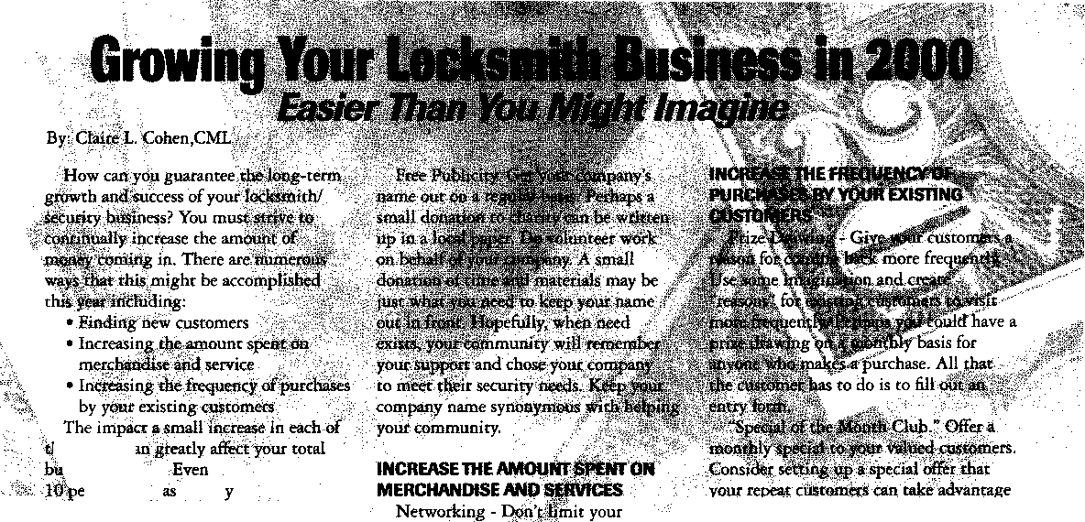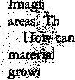

The Trilogy from Alarm Lock is one of many players in the growing market of keyless electronic locksets. Compared to the new electronic locksets, the push button mechanical combination locksets of earlier generations had similar limitations to keyed mechanical locks. When more than one person has access through the same door and lock, the mechanical key issued to one person is normally identical to the keys issued to everyone else with keys to that door. On a keyless mechanical lock, the combination used by one is the same used by everyone else with access. When someone quits or is fired, changing the key or combination to lock out that former employee also locks out everyone else’s key or combination. This means new keys or combinations have to be reissued to everyone.

The microprocessor of an electronic lockset allows many different combinations or (electronic) keys to operate the same device. It is typical that the key or combination of the fired employee can be programmed out of the system without anyone else being affected. All they would know was that their keys or combinations still worked. Whether

any particular individual was locked out or had their key or code changed would not be readily apparent to anyone whose key or code was not changed.

Although there are many individual variations in the Trilogy line, they can be divided into two basic models by their capabilities. The T2 is programmable only at the keypad, while the T3 has an audit trail and makes use of computer software through an outside device to program or audit the lock. Most of the individual variations are avail­able on both T2 and T3 locks. The mechanical key override cylinders for both are available in many different IC cylinder styles and commercial keyways. Both are available in water proof versions for exterior door installations.

Photo 1 shows the T2 DL2700WP. It is the water proof version of the T2. Among its features, it has a clutch mechanism and is battery operated. It has programmable access codes and functions that include: multi-level user capability, master code, manager code and up to 15 different group or individual codes. It has a passage function, and a one time use emergency or service entrance code can be



Keynotes

March 2000

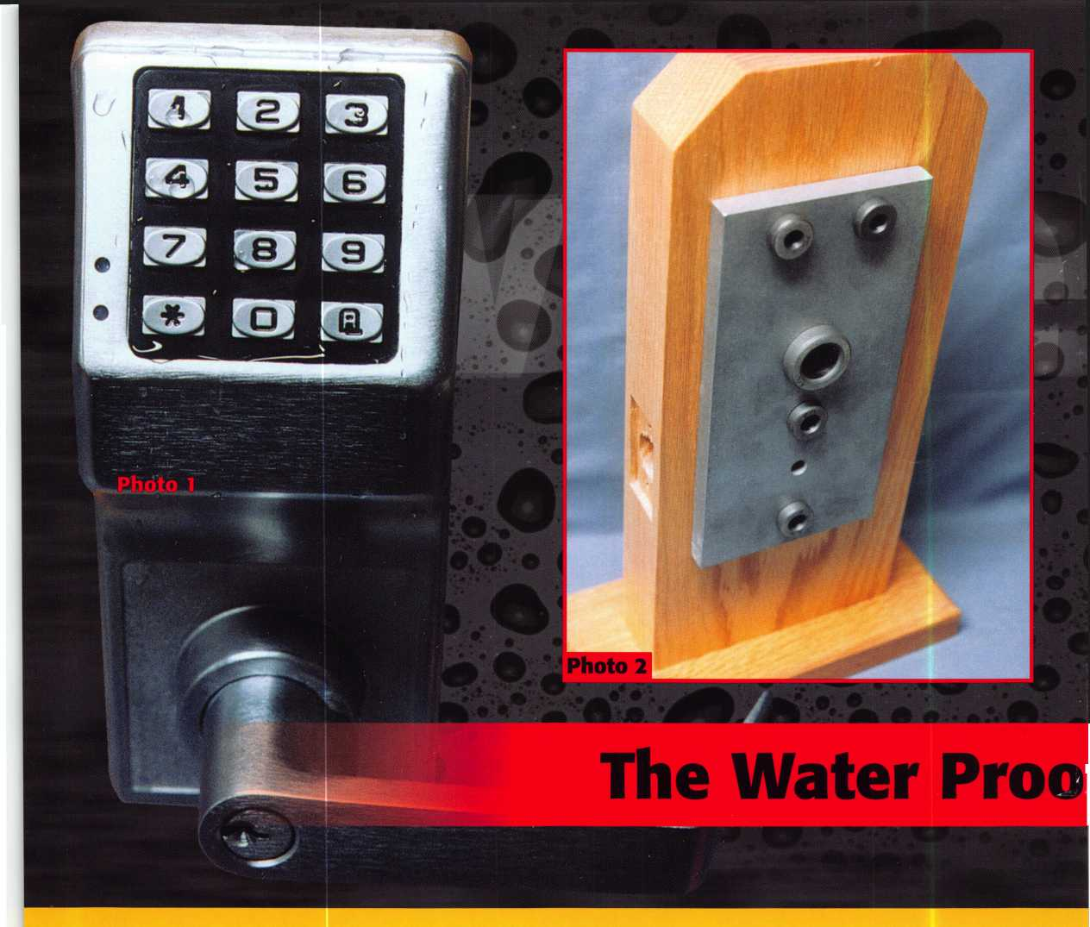

Photo 4

Trilogy from Alarm Lock- Part 1

.alii

**by Sal Dulcamara, CIVIL**

*mm*

programmed which erases from memory after it is used. The keypad and circuitry are protected from water and moisture, besides many other features.

In part 1, this month, I will explain the installation of the lock. Next month, in part 2,1 will explain the programming.

The installation procedure for both the T2 and T3 (water proof and not) are basically the same, although there are a few differences here and there.

Installing the Trilogy

The Trilogy is somewhat oversized in comparison to a standard keyed mechanical lockset. Additional mounting holes are required when retrofitting a standard lock prep. Photo 2 shows a special lock installation jig available from Alarm Lock. It is part #DL2700DJ. Although not shown here, it is recommended that you use a square to make sure the installation is straight. Also, a clamp should be used to keep the jig from moving around during drilling. Five additional holes are needed beyond the existing 2 1/8 inch

diameter cross bore hole. The four smaller holes are for mounting and the one larger hole is for the wiring. Photo 3 shows the additional holes drilled on the lock mount, and the back (inside) surface of the jig. A protruding 2 1/8 inch diameter piece of metal fits into the existing cross bore hole to aid in alignment. The guide holes have bushings to keep the holes from enlarging, and should help to keep the through holes in a relatively straight line through the door.

Photo 4 shows the lock body. With a poke tool, I am pointing to the three plastic spacers that come pre-installed for a standard 1 3/4 inch thick door. For a 1 3/8 inch door, one spacer should be removed. A 1 7/8 inch door requires an additional (included in package) spacer to be added. The factory should be consulted for other door thickness. The outside keyed lever must be removed to add or remove spac­ers. Also, the handing of the lock is field changeable. Changing the handling of the lock also requires that the outside lever be removed first. Once the lever handle is removed, the lock chassis and the outside spindle should be rotated 180 degrees so that the latch retractor is facing the

Keynotes

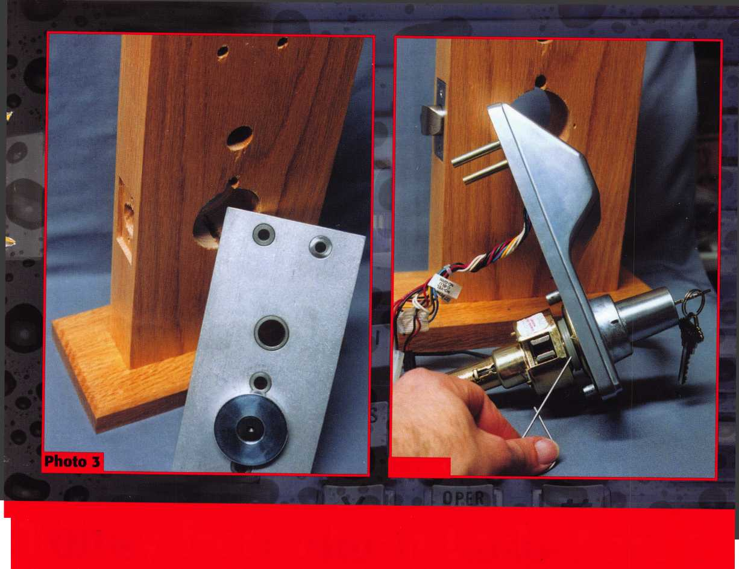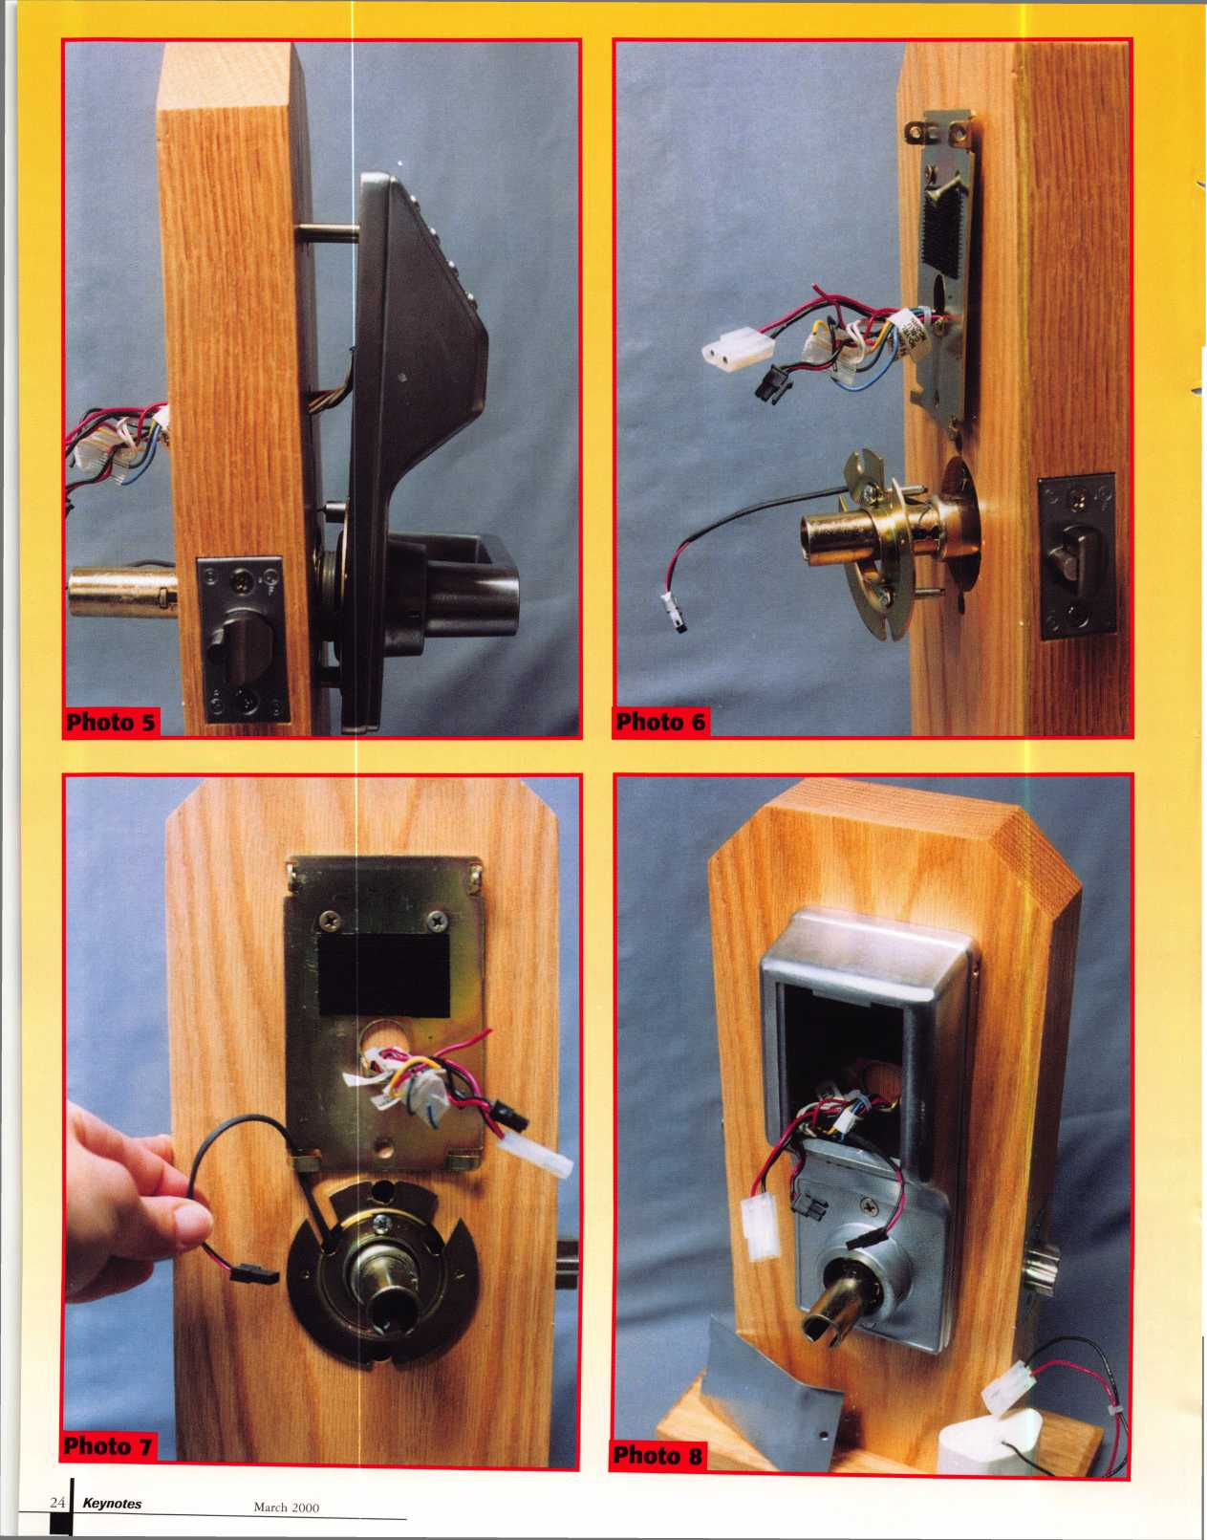

opposite direction. Then reassemble the lever handle. The lever handle is removed and reinstalled like most standard locksets. The key is turned about 45 degrees and the poke tool is used to depress the spring loaded retainer through an access hole.

The lock body is lined up with the mounting holes as in photo 5. The latch retractor on the chassis must connect properly with the latch which was already installed. The connector cable hole is 3/4 inch in diameter, but does not line up directly with the spot where cables protrude from the lock. It threw me at first. I thought that the hole was too low. If you look closely at photo 5, you will see that the bundle of wires is slightly bent or creased. The wires are initially bundled together in a circular pattern as if one large round cable. You will need to spread and flatten the cluster of wires in order to install the outside housing. Be careful not to cut the wires while installing.

In photo 6, the inside mounting plate surrounds the cluster of cables (which fit through a hole in the plate), while the motor wire protrudes from a gap in the inside rose plate and is attached to the chassis further inward. There are more wires than needed for standard operation, but some are used for special optional functions of the Trilogy.

Screws fasten the inside mounting plate and inside rose plate, in photo 7. Just as on the outside of the door, the round bundle of wires will need to be spread and flattened in order to properly attach the inside mounting plate without damaging the wires. The motor wire fits through a cutout in the inside rose plate and fits under a tab toward the bottom of the inside mounting plate. The tab keeps the motor wire from slipping out. The wire will not easily slip into place if the screws of the inside mounting plate are fully tightened

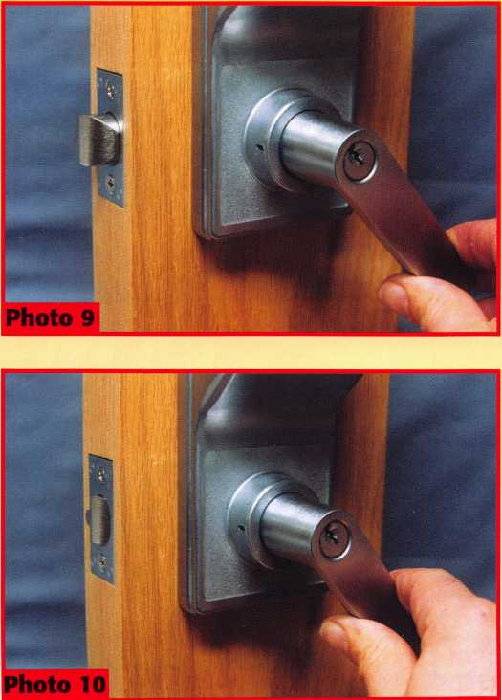

before slipping the motor wire under the tab. The inside housing is attached at the top with two small screws to the inside mounting plate, and two much longer screws through cutouts in the inside rose plate and into the chassis just beyond the rose plate. With the inside housing in place, in photo 8, the installation is almost complete. The connectors (black plastic ends) for the motor wires should be connected, as should the battery cables (white plastic ends). It is recommended that the connectors be sealed with Dielectric Grease which is included in the package. There are five AA batteries in the white plastic battery case. The batteries are encased in plastic in the water proof Trilogy, but wouldn’t necessarily be attached the same for the versions that aren’t water proof.

The battery pack and loose wires should be placed into the cavity of the housing. It is a slightly awkward fit, so be careful not to force anything that would cause damage or cut the wires. The metal battery pack cover will hold the contents inside, so you don’t need to pack things unnecessarily tight. The cover is held with a single screw. Next, the inside lever handle is attached and the lock is fully assembled. If you are making use of some of the special functions of the lock, you might end up connecting some of the loose wires in the bundle to other components outside the lockset itself.

The Trilogy uses a clutch device, and without inputting a correct code, the outside lever moves freely without actuating the latch. Photo 9 shows the outside lever handle turning while the latch remains extended. When a correct code number is input, moving the handle will retract the latch, as in photo 10. The actual operation and programming of the Trilogy will be explained in part 2, next month.

***SPEEDY PIK«***

The Automatic Key Identification System  
Connects to Your IBM® compatible computer

Key ID

Simply turn the lever, insert the Customer's key and  
release the lever. The IMAGE SENSOR will take a  
picture of the tip of the key, scan the database and  
within seconds display the exact match. It will then  
tell you what hook the blank is on and what the key  
name is. The INVENTORY tracking program, will ask  
you how many keys the customer wants, it will  
calculate the total price, subtract the quantity of cut  
keys from inventory and when it reaches the  
preprogrammed minimum it will record it on the  
reorder form, which is generated automatically. The  
program will also tell you where to insert the key in the  
key machine (jaw side) for quick accurate duplication.

[www.speedypik.com](http://www.speedypik.com)

For more information call (617) 567-1111 or send fax (617) 277-7777

E-Mail: [speedypik@aol.com](mailto:speedypik@aol.com)

March 2000

Keynotes

Need information in a hurry?

Just call 310.575.5074 and you will be faxed:

#1 A list of all documents available through this service  
#2 Becoming A Locksmith  
#3 Locksmith Career Summary  
#4 Locksmith School List  
#5 ACE Class Schedule  
#6 Certification Information  
#7 PRP Category List  
#8 ALOA Membership Application  
#9 ALOA List of Benefits  
#10 Scholarship Application Form  
#11 ALOA Video Library Order Form  
#12 ALOA Membership Items Order Form  
#13 Safe & Vault Technicians Association  
Member Application/Subscription Form  
#14 ALOA Chapter Roster  
#15 Legislative Action Network  
#16 Legislative Action Network Newsletters  
#17 Various State Laws  
#18 Industry Position Paper

Your association continues to explore  
ways to provide you, our members,  
with new benefits and services.

ALOA  
HAS  
FAX 0l\l  
DEMAND!

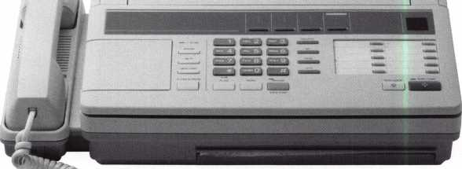

**BE A PART OF 1.800 LOCKSMITH! USE THIS NUMBER IN YOUR CITY & OWN THE MARKET!**

We are looking for qualified locksmiths who want to expand their business and develop themselves into one of the largest locksmith operations in their city. You will be authorized to use our logo and name and we will advertise for you on radio and television.

Insterested locksmiths will be able to “secure” as large or as small a territory as they desire. Territories will be based on zip codes.

**[WWW.](http://WWW.1800LOCKSMITH.NET)**[1800](http://WWW.1800LOCKSMITH.NET)**[LOCKSMITH.NET](http://WWW.1800LOCKSMITH.NET)**

**Call today for more information or to sign up!**

Keynotes

March 2000



*mm*

**THE COMPLETE**

**CCTV PROGRAM ON CD-ROM  
FOR STAFF TRAINING AND**

**PRODUCTIVITY ENHANCEMENT**

STAM Insight has been developed to enhance CCTV skills and productivity with many different uses.

Productivity

W System Drawing I# Estimation **•** CCTV Training €1 CCTV Reference H Sales/Demo t# System Design t# Staff Evaluation

Demonstration Tool

Estimation

*Drawing*

Internet Enabled

|  |  |  |
| --- | --- | --- |
| [ CCTV Content | 10 hours | | 10 hours |
| CCTV Calculators |  |  |

**Sold in Over 50 Countries**



Distributed by:

3003 Live Oak • Dallas, TX 75204 800-532-2562 [www.aloa.org](http://www.aloa.org)

COPYRIGHT © 1996 Security Training and Marketing Pty Ltd. All rights reserved ACN 057 006 541



□ Yes, please send me a FREE PREVIEW CD ROM

Name:

Job Title:

Organisation:

Address:

Country Tel: (

.Zip/Postcode,  
.e-mail

Fax: ( )

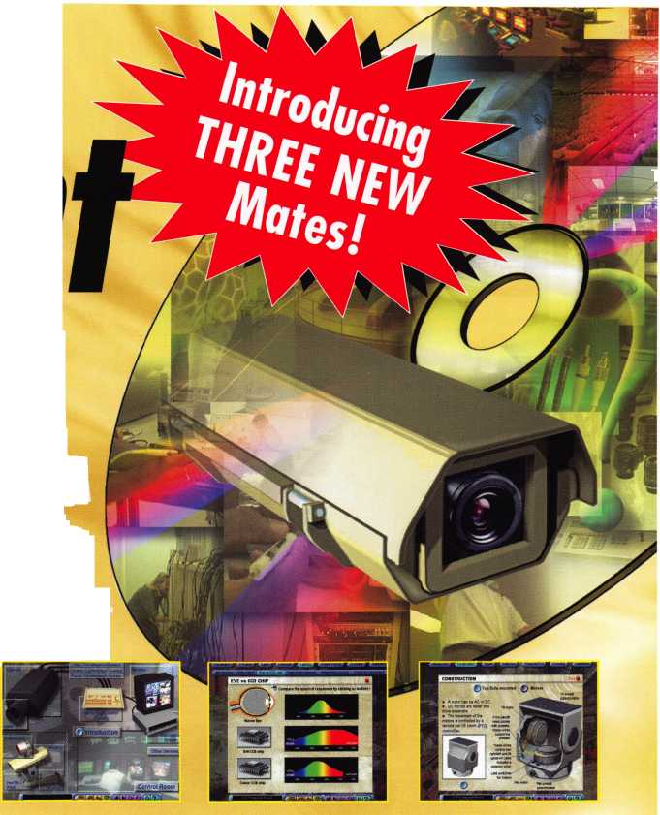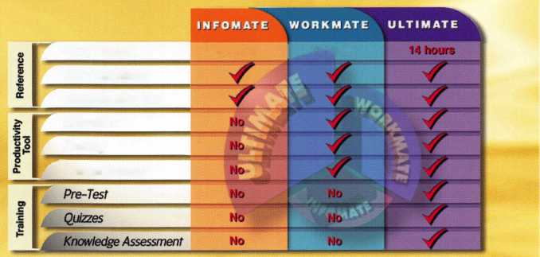

The Northern Melbourne Institute of TAPE.

***How many times have we wondered about the practices of locksmiths in other parts of the world? Is our training the same? Is this basic craft the same? The answer is quite simple***

Locksmiths Down Under

**By Michael A. Ferrill**

***Keynotes***

**March 2000**



\

H

ere in America, people become locksmiths by taking  
correspondence courses or through practical hands on

experience at vocational technical schools or college  
campuses. With that in mind, I often wondered how other  
countries train students to become locksmiths.

To find an answer, I immediately dispatched numerous letters to every major foreign technical school or locksmith college identified in the 1/99 Locksmith Ledger International Security Register. Within three days an immediate response came from Mr. Garry Wilson, Senior Instructor (Professor & Lecturer) from the Security Technological Section, of the Northern Melbourne Institute of TAFE, located at Bell Street and Waterdale Road, in Heidelberg Vic 3081, Australia. Mr. Wilson was kind enough to answer a few of my questions concerning the training of locksmiths in his country. The common denominator in both American and Australian training is that we all start out as apprentices.

America does offer numerous schools that produce some of the finest locksmiths in our country. But we should never assume that we are indeed the best in the world. Although I might add that there are some of us who think so. Some countries like Australia, have imposed rigorous educational requirements and higher technical hands-on training programs required and necessary before any person can really call himself or herself a locksmith.

Lets review the training a locksmith student at the Northern Melbourne Institute of TAFE receives. The institute is similar to an American community college. The Locksmithing Department has about 150 students. There are 4 main campuses with a total student population of 25,000

The teaching staff of this institute includes Max Cherry, the Department head. Mr. Cherry holds a Certificate of Proficiency in Locksmithing, and a Graduate Certificate of Security Management, he is a member of the Victorian Security Institute. Senior Teacher/Lecturers include Garry Wilson, Leigh McGrath and Richard Hird. All of whom hold Certificates of Proficiency among other honors. I have to admit this is a very strong teaching staff for this type of technical college. Each member is certified and trained to teach in this highly skilled technical field. The Locksmith Apprenticeship Course is an extensive three year part time program of a four year apprentices program. The course itself comprises three years of intensive study in various basic locksmithing skills. The apprentice student signs an agreement with their employer and the training provider which lasts four years. The employer releases the apprentice with pay to do the training all of which is subsidized by the Government.

For example the first year alone begins by having the student train in the following core subjects:

Introduction to Locksmithing  
Lockfitting (installation techniques)  
Lock Mechanisms  
Lever Lock Servicing  
Locksmithing Workshop Skills I  
Locksmithing Workshop Skills II  
Client Relations  
Communication & Industrial  
OH & S  
Machining

40 hours 40 hours 40 hours 20 hours 20 hours 40 hours 20 hours 40 hours 20 hours 40 hours

Ten classes for a total of 320 hours practical hands on training.

The second year covers  
such topics as a Lock Fitting  
Metal section, Lock  
Manipulation, Lock  
Mechanics, Masterkeying,

Security surveying, Auto  
I & II, Computing, and  
Safe training for another  
320 hours. The third year  
covers Electrical, Electric

locks and Strikes, Safe Service,

Safe Key Locks, KCL, Safe Opening, Welding, Alarms, and  
Quality concepts for another 320 hour, totaling 960 hours of  
hands on technical training.

To receive an Advance Certificate in Engineering (Lock-  
smithing), an additional two year part time program is required.  
Applicants to either program must have completed training or be  
of a mature age (at least 25 years of age). A student must complete  
an additional 16 courses in advance studies totaling 620 hours,  
above the apprentice level.

Reference books used in these courses are developed within  
the institute to suit individual classes by the lecturers. Cost vary,  
subject to classes a student takes. Apprentices will pay a minimum  
of $317 in Australian dollars for a Certificate in Engineering,  
and an Advance Certificate in Engineering cost $327. Industry  
based courses are priced as they are run. Similar to our Regional  
Training Programs offered at our Regional Locksmith & Security  
Annual Conventions.

I should point out that the courses and modules are  
nationally accredited by the government and the industry and  
the Institute. Northern Melbourne Institute of TAFE is a  
Federally funded institute.

As for associations or trade organizations, most Australian  
locksmiths belongs to either the Master Locksmith Association  
of Australia, the New Zealand Locksmith Association or the  
Locksmith Guild of Australia.

They read the following Locksmith trade journals: The  
Locksmith Ledger, The National Locksmith, Safe & Vault  
Technology, Keyways (UK) Security Australia, Security  
Insider and Keynotes.

I guess we could all ask a thousand questions about our  
brother locksmiths in Australia but what I have found out about  
this wonderful group of men and women in the land down under  
is that they face the same problems, ask the same lock questions,  
deal with the same security issues we all face in providing the  
best security the home owner.

The home owner could live in McKinney, Texas or in North  
Melbourne, Australia. Both of these home owners will still depend  
upon their families safety and security by trusting their local  
Locksmith for professional advice.

As Mr. Garry  
Wilson would say  
“have a good day mates”  
and “don’t take life so  
seriously - its not  
permanent.” Good luck  
and Best Regards to our  
fellow locksmith in the  
Land Down Under.

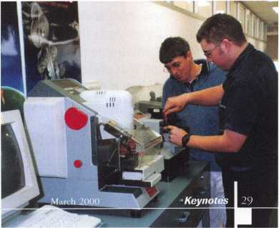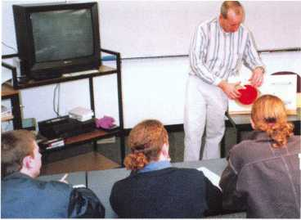

It is confusing and most companies are just now beginning to see some light in this new tunnel of technology. To make a quick answer to these questions, there is a place on the web for you and you can do it yourself. The best thing is that it can be done for free! In this article, we are going to examine as much of it as space allows.

If you are like myself, e-commerce presents itself as a big sphere that seems impenetrable. At first we see it as magic, a web dream! Here is a place that I can have something that will work for me and make me money. Everybody is talking about how much money you can make and it is as easy as making a home page and being there. If you are like myself, it all sounds too good to be true. It is! The web is not any different than your local advertising agency and a storefront window. I am going to be hard on the web here since you, as a locksmith, will not really sell your product as Amazon.com does. To think that someone will buy hardware from a locksmith on-line is probably taking things too far. There may be some of this going on but you will not pay for your web presence this way. Your presence on the web will, for the most part, be an intangible return. You could run

specials for products but your real payoff will come by way of promotion. Let me take these two points and expound on each before we go into the process of producing the actual web presence.

**Business Promotion**

A service-oriented business with a website can accept a simple fact. It has a presence and it is there to promote its existence. Nothing more can really be expected. This presence can however be very powerful. First, it can be done for free. Secondly, it can be done with links. Links are a place on your web page that allows someone visiting your page to "click" with their computer's mouse and go to another location within your site or to go to another site on the web. Let's say that your church's web page offers their congregation a link to individual web pages. When an individual of the congregation visits the church's web page, getting the information on the weekly sermon, they may click on a link to your site to find out information on you and your business. Now, a church may not be the right place to promote a business but it makes a good example.

■■■■I

mm „



Keynotes

March 2000



**Locksmiths, as with so many business  
entities, seem to be lost and terribly  
confused when it comes to the Internet\***

**The questions many of us may be asking are:**

* **Do I belong on the Web?**
* **Can it help my business?**
* **How do I promote myself?**
* **Do I sell my locks?**
* **Which way do I turn?**

**t Can I do this myself or do I need to  
spend money to have a web site?**

You need to find organizations or businesses within your community where the sharing of links can be a mutual benefit. The sharing of links, in effect, takes the place of a monetary exchange. Lef s say you're linked to a local alarm company and they in turn link to your site. It is a mutual agreement and mutual benefit. You may belong to the Elks or Lions or another club. Get them to link to your site and you link to theirs. It may your insurance agent's site or your local hardware store's site. It is important to remember that sometimes linking can cost you some money since the website you are linking from may require placing a banner ad or another type of advertising element. You have to decide the profitability of this kind of move. Should you do some work for a non-profit organization, as a donation, then have them link to your site with a short word of thanks in their web page. If you can do it, get the local Chamber of Commerce to give you a link.

It is important to use your community influence to get connected to as many sites as possible. Being on a search engine that is accessible around the world is going to do little except the boost your ego and take up a lot of time answering email questions. Your website can be located anywhere on the

Internet and still be accessible to anyone in your community who knows your web address. Now that you are promoting your business on the web throughout your community and you have the links, whaf s next?

**Running a Special**

It is crucial to understand that a website can only help you if it is visited. When was the last time you, the business owner, did some physical networking? If you're like me it was only with the last customer. Success in any business means being good at what you do, doing what you do in a timely manner and going out of your way to meet and converse with your fellow man. This is a simple but scary scenario. Let me not be too simplistic here since being good at finances will only enhance your chances at success.

Since visitation is paramount in a successful website, you need to offer something to keep the visitation happening. We need something that is constantly changing. Since money is always of grave concern to everyone and a deal is everyone's dream, let's make a deal! What happened to monthly deals that once graced the storefront windows? It would make a good practice here!

March 2000

Keynotes



Let's take an example.

Once you have gotten your website up and running, you begin to get the word out that you have such a creation and you want to have people start visiting. Your pride alone will get the attention of relatives only. Well let's give everybody a deal. Why not run a padlock special. Something the majority of your business customers might be inclined to use. How about a Master or American rekeyable padlock. You pick one and write about all it can do for a business and how it can be implemented into a master key system and you detail the deal for monetary savings. You then have contact in person or by phone with your business clientele. You ask them to visit your site and examine the offers while enjoying the security information that you have posted on the site. If they like the offer on your padlock special, they can click on a link on your padlock deal page and they can send you an email requesting more information. You will probably have to call them back and get some details. Part of the deal is that you will deliver the specials during a particular week. You get all of the orders put together by a particular date that you have set and you place the order. Upon arrival, you do your thing by keying up the padlocks to satisfy the orders. Then, you offer free delivery since you can deliver on your rounds or other service calls. Remember that the web is worldwide. Make your deals and be certain to specify that they are only for your area. Should you find a way to make others happy somewhere else in the world, that7s great. Just don't forget the cost of shipping. As time goes by, you will find out what products will work well and which ones will not. The idea is to find ways for clients and prospective clients to visit your site. It is just like advertising except it is free!

**Finding a Web Host**

To actually sell locks over the web and have a return that will pay for the site would not be realistic at this time.

I say at this time since the web and the services for doing this type of retailing are not well enough entrenched for the small business owner to afford them. To have a "store" on the web will run a business $100.00 a month to advertise about 50 products with security for the use of credit cards by your clientele. More products and the monthly price simply increases. Compare it to Yellow Page advertising.

To have your own domain name (example: HYPERLINK <http://www.dennislocksmith.com>), will require a one-time fee of $70.00 to the Domain Registry Company and then to stand alone with this name you will have to pay a monthly fee of about $25-$50 for your own site. Several major site providers as well as some local providers could accomplish this. There are free sites where you use the domain name of the site with a suffix to identify your pages. I'll go into this area in a moment.

Things are always changing and a very good example of this deals with domain registry. The $70.00 fee will someday be a free service. This will probably occur early in the year 2000 but be sure there will be some other catch that you will have to pay for. Also remember that the more a product is used, the lower the price of that item becomes. This is true with the Internet providers as well. In the beginning, the Internet providers, like America On Line, were charging us by the minute to be connected. We were also paying outrageous phone bills to make the connection through our long distance phone companies. Currently, we can be connected for somewhere in the vicinity of $20 to $30 per month depending upon our choices. Let's go beyond spending money and deal with the free concepts.

There are some drawbacks to "free." If someone is going to offer you something free, they want something in return for doing without the money. Let*s take an example. If I were to use Geocities for my free server provider then my web address would be HYPERLINK <http://www.geocities.com/> denniswhatever [www.geocities.com/denniswhatever](http://www.geocities.com/denniswhatever). At first your reaction to using a provider where your name comes after their name is not all that appealing. Not only does it make for a long name to type but also half of it is their name! Well, remember it is "free"! You will also find that with free sites you will have to put up with a banner advertisement at the bottom or top of each page you have. Now if you can get past this part then "free" may be your ticket to the web. Remember that once someone visits your site and likes it, they will probably make it one of their favorites or bookmarks saving your location within their program so they will not have to retype the address.

Many of the free site providers will also have a program built into them that will allow you a quick means of producing your web page. It is a Web Page maker that is easy to use in most cases and utilizes a drag and drop technique. A friend told me that if I really had difficulty with this concept, I should humble myself and ask a 10-year-old for some help. There are many professional web page designers out there that we could hire to produce and manage a website for us. They want you to think that they are the only ones who can do it since they would argue that we do not have the expertise and that our perception of it all is nothing but wishes and clicks! You will find doing your own website an enjoyable experience and a lot of fun once you are over the initial intimidation. You will be able to add to it or delete from it whenever you wish and pay nothing. You can always go to friends and other locksmiths within you local associations for a little help. In the end, you will be capable of producing and managing your own website and make it into a very useful tool of business. It is a tool that will yield friendships and profits.

Keynotes

March 2000

BUSY’S NOT THE WORD!!!

Overwhelmed would be the word to use in describing the first month of this year’s legislative onslaught. Currently, ALOA is actively working to defeat detrimental bills in Tennessee, Mississippi and Ohio (has yet to be introduced), and beneficial bills in Illinois and Kentucky.

ALOA is working hard in getting bills beneficial to locksmiths passed, and the harmful ones killed. The success stories tend to be those where Legislative Action Network (LAN) members, chapters, regional locksmith associations and the ALOA Headquarters work together. This has been true for all the states mentioned above, especially with Kathy Zaniolo, CPL and the Allied Locksmiths for Illinois.

Take a moment and see what’s happening in your state!

LEGISLATIVE UPDATE

All bills that saw movement between 01/01/200 and 02/04/2000.

ALABAMA S91

SUMMARY: Relates the Alabama Sunset Law; continues the existence and functioning of the Alabama Electronic Security Board of Licensure with certain modifications; clarifies the exemption of any person of business entity that only sells alarm systems at the premises of a customer, but does not enter the premises, or install, service, or respond to alarm system at the premises.

STATUS: 02/01/2000 INTRODUCED.

02/01/2000 To SENATE Committee on GOVERNMENTAL AFFAIRS.

ILLINOIS S452

SUMMARY: Amends the Private Detective, Private Alarm, Private Security, and Locksmith Act of 1993; provides that an agency may employ a person under the act if the person possesses a valid permanent employee registration card or if the person has a valid license under the Act; provides that nothing in the Act prohibits police, fire, or other municipal employees from opening a lock in life-threatening circumstances, and opens up the grandfa­thering period.

STATUS: 01/27/2000 From HOUSE Committee on RULES: Approved for consideration.

01/27/2000 In HOUSE. Placed on Calendar Order of Second Reading.

01/27/2000 In HOUSE. Held on Calendar Order of Second Reading.

02/02/2000 In HOUSE. Amendment No. 3, 4, 5 filed. To HOUSE

Committee on RULES.

02/02/2000 In HOUSE. Held on Calendar Order of Second Reading.

KENTUCKY H409

SUMMARY: Requires locksmiths to check identification of a person requesting services and to record information relative to the transaction.

STATUS: 01/20/2000 INTRODUCED.

01/20/2000 To SENATE Committee on RULES.

01/21/2000 To HOUSE Committee on LICENSING AND OCCUPATIONS.

01/26/2000 From HOUSE Committee on LICENSING AND OCCUPATIONS:

Reported favorably with substitute.

01/28/2000 PASSED HOUSE on to SENATE

02/03/2000 To SENATE Committee on LICENSING AND OCCUPATIONS:

MISSISSIPPI H439

SUMMARY: Regulates the installation and service of burglar alarm system; defines certain terms; creates the Mississippi electronic security board of licensure and provide for it membership and administration; provides the powers of the board; provides licensing requirements; provides exemptions from this act; provides for violations of this act; provides for uniformity; provides for its administration.

STATUS: 01/20/2000 INTRODUCED.

01/20/2000 To HOUSE Committee on JUDICIARY B

TENNEESSEE S2926/H2509

SUMMARY: Creates Class A misdemeanor offense of unautho­rized duplication of safe deposit box key or unauthorized possession of safe deposit box keyblank stock and keyblank molds.

STATUS: 01/24/2000 FILED.

01/24/2000 INTRODUCED.

01/26/2000 To SENATE Committee on COMMERCE, LABOR AND AGRICULTURE.

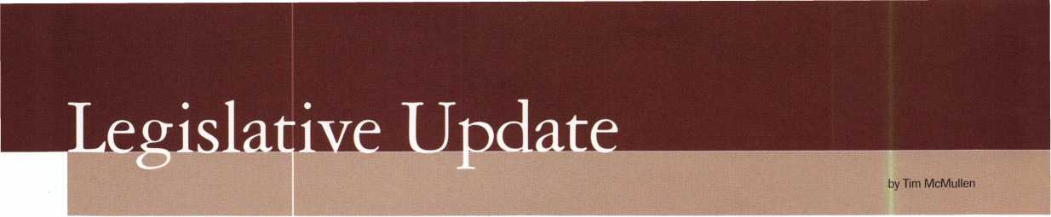

You're a professional locksmith, not a professional lobbyist.

Vbf/ can't te on the steps of every state capitol and walking the halls of the federal government to protect four profession, but.

**We can. Contribute to ALOA's legislative program.**

**Become an ALOA legislative action network volunteer.**

**See just how far our legislative arm reaches out for you!**

The ALOA Legislative Action Network (LAN) Needs your support for the Voice of Our Profession.

The ALOA Legislative Action Network is constantly working to influence legislation that’s important to the locksmithing profession. We are working in your best interests to promote legis­lation that will have a positive impact on our proud profession; while preventing or limiting legislative efforts that are harmful. It is an ongoing process on both state and national levels, and has achieved many successes in the past.

Working around the clock on your behalf of the profession takes time, talent and financial resources. We need your help in all three of these arenas to ensure the success of our legislative program for 2000-01!

It’s an Established State-by-State Connection!

Legislative Action Network members are our best resources at the grassroots level for effecting change.

Members monitor each state legislature for bills affecting the locksmithing profession, including related industries.

Members organize media contact which helps the public understand our profession.

Members speak out on your behalf to state legislators; organize letter writing campaigns; and keep everyone informed in state and regional locksmith associations.

Members assist the national ALOA office with state fundraising campaigns in situations where our profession is faced with detri­mental legislation and a lobbyist is deemed necessary to assure success.

What our success means to You

ALOA’s Legislative Action Network has achieved great success in many state and federal legislative initiatives largely in part to the incredible involvement by our LAN members. Nearly every state has reaped the benefits of ALOA’s strong legislative efforts.

How You become involved

In a recent, 75% of ALOA members stated they believe “...it is ALOA’s responsibility to protect the locksmith industry from objectionable legislation.” With that hefty responsibility comes the liability of funding legislative programs. Grassroots lobbying campaigns cost money and to continue our successes, we need to continue your continued support!

YES! I support ALOA in its fight against legislation that is bad for locksmithing—bad for my business!

Enclosed is my donation in the amount of: ZD $25 ZD $35 ZD $50 ZD $75 DZ $100 ZD Other $_

Indicate type of funds: ZD MasterCard ZD Visa ZD American Express ZD Check ZD Money Order

Credit Card Number: Expiration Date: /

Name (as it appears on card):

Signature:

ZD Please use my donation in my state ofexclusively.

Federal law mandates that political donations are not tax deductible.

Please make checks payable to “ALOA LEGISLATIVE FUND.”

13 Mail this completed form with your donation to:

ALOA LEGISLATIVE FUND, 3003 Live Oak Street, Dallas, TX 75204.

March 2000

Ml Keynotes

While a monetary contribution is not required to be involved in ALOA’s legislative activities, it is encouraged so that we can continue to work effectively on behalf of every ALOA member nationwide. If you contribute $14.95-99-95 to the Legislative Action Fund, you automatically become a member of the Legisla­tive Action Network (LAN). The LAN is an important tool in raising the standards of our profession through the legislative process by making sure that locksmiths have the final say in how our industry will be run. As a LAN member, you will receive:

* Ten issues of the Legislative Action Network Update alerting you to important legislation in your state and around the country.
* Networking opportunities with ALOA members who share the belief that legislative involvement is important to the effectiveness of our association.
* A listing of your state representatives and senators including capital and district addresses, and phone and fax numbers on both hard copy and disk.
* A comprehensive guide to lobbying in your state capital, so you can be the “voice of ALOA” to legislators.
* LAN stationary and envelopes for sending official letters to legislators, lobbying on ALOA’s behalf.
* A lapel pin designating you as a special ALOA LAN member.
* Recognition in Keynotes magazine.
* An invitation to an exclusive reception at the annual ALOA convention for LAN members.

When You donate $100 or more, you become part of the heart of the legislative program through LAN membership and receive the following:

* A reserved place of distinction on the special LAN Council that participates in determining ALOA’s legislative direction.
* Direct input into the legislative strategic plan that guides all legislative activities.
* Discounts on ALOA bookstore items and a 10 % rebate on all ACE classes.
* Complimentary Legislative Convention merchandise.

It’s easy to do Your part

We need you as a Legislative Action Network member and financial contributor to ALOAs legislative program. Please use this form to remit your contribution. We greatly appreciate your generosity and will continue to give our greatest effort in protecting your profession.

Thank you for recognizing the importance of the ALOA Legislative Action Network and providing your support!

Keynotes

Classified



Dept

**f Classified Advertising Policy**

**Classified advertising space is provided free of charge to ALOA members, and for a fee of $.60 per word, $15 minimum for non-members. Classified ads may be used to advertise used merchandise and overstocked items for sale, “wanted to buy” items, business opportunities, employment opportunities/positions wanted and the like. Members or non-members wishing to advertise services or new merchandise for sale may purchase a “Commercial Classified Ad,” for a fee of $1.30 per word, with a minimum of $40. Each ad will run for two issues. For blind boxes there is a $5 charge to members and non-members. All ads must be submitted in writing to the ALOA office by the fifteenth of the month, two months prior to issue date. Send to** Keynotes **Classifieds, 3003 Live Oak St, Dallas TX 75204-6186. ALOA reserves the right to refuse any classified advertisement that it deems inappropriate according to the stated purpose of the classified advertising section.**

■ EMPLOYMENT

Locksmith Wanted

3/F/3: Busy shop in Woburn, MA has immediate opening for self-motivated, reliable Locksmith. Large customer databases for Automotive, Commercial and Residential accounts. Applicant must have own van and tools. Guaranteed 50% commission. Great opportunity for the right individual. All inquiries kept strictly confidential. Send resume to:

Locks & Keys Inc PO Box 222 Woburn, MA 01801 Jobs@ locks-keys, com

Locksmith Wanted

3/F/3: Small company experiencing growing pains. We need good, clean locksmiths and safe technicians to grow with us. Looking for those familiar with general locksmithing and/or specialty areas. Will train if necessary. Fax or mail resume and pertinent information. Starfleet Lock & Safe PO Box 3324 Springfield, IL 62708 (217) 726-7233 fax

Security Technicians Needed

3/F/3: Get lucky and work in booming Las Vegas. Great weather, great income potential for experienced, motivated hardworking Technicians and team players. Paid holidays, vacation, medical, 40IK plan and in house training. Don’t delay, fax your resume today.

Liberty Lock and Safe 3470 W. Sahara Ave Las Vegas, NV 89146 (702) 871-3397 (702) 876-3470fax http:!iwww. liberty lock, com

Security Locksmiths Wanted

3/F/3: If you are a professional Security Locksmith (CML, CPL, CRL, RL), and desire to team up with the best, then JOIN US for a most rewarding career. Our full-service commercial security services include Locks, Keys, Safes, Alarms, CCTV and Access Controls.

We do take care of our customers security needs, therefor we also provide some residential and automotive work. We are a solid company with an excellent compensation and benefits package for all our team members. Constant training, cross training and upgrading in all skills generates high income and a solid future. Send or fax resume.

Ace Lock and Key Service 1201 S Casino Center Las Vegas, NV 89104 (702) 382-1734 ace lock @earthlink. net

Experienced Locksmith Wanted

3/F/3: Experienced locksmith needed in Denver and surrounding areas. Commercial work and some residential, no automotive work. Excellent pay and benefits. Good driving record a must. Electrical and access control experience a plus.

Steve Luebbers S &L Lock & Key Inc 7290 Osceloa St Westminster, CO 80030-3229 (303) 429-0963 (303) 429-0708fax

Qualified Apprentice Needed

3/F/3: If you have some training as a locksmith and are willing to work hard and learn fast; and if you desire to team up with the best, then a rewarding career awaits you. We are a full-service commercial security service (Locks, Keys, Safes, Alarms, CCTV and Access Controls), over 30 years in Las Vegas. We also provide some residential and some automotive work. We offer our full time employees an excellent compensation and benefits package, including a retirement plan. Under constant training, cross­training and upgrading in all skills, high incomes are common and a solid future assured. Excellence is our standard, therefor, a drug test and a criminal background investigation will be required. Send or fax resume to:

Ace Lock & Key Attn: Harold Lord 1201 S. Casino Center Las Vegas, NV 89104 (702) 382-3963

■ WANTED TO BUY/SELL

Tryout Keys, Depth Keys For Sale

3/P/3: Aero Lock does not use key duplicator machines to produce its tryout keys or depth keys. Only original computer controlled code cut. Buy the best.

Aero Lock

3673 New Getwell Road # 9 Memphis, TN 38118 (800) 627-9433 (901) 362-1197 fax aerolock @ix.netcom.com <http://www.aerolock>

March 2000

361 ***Keynotes***

HPC Punch For Sale

3/F/2: Brand new HPC Punch for sale $1000. Free shipping, with all cards etc. waltthom @altamaha. net (912) 375-3331

Key Machines Wanted

3/F/3: Wanted Ilco, “Minute” or “Turrett” key machines, complete or parts.

John T. Grist, CML, CPS (800) 896-6266 security @ acme-brain, com

Safe Door Wanted &

Misc. For Sale

3/F/3: Looking for 8” round bottom door for Gary Safe (money chest) or will sell safe.

For sale, Russwin CL3600 series locks, sever­al key machines (manual, automatic and mini’s). Call for more information.

Priority Lock & Key (817)535-0289

« BUSINESSES FOR SALE

Businesses For Sale

3/P/3: Sun Country, very busy Locksmith business for sale on the Gulf of Mexico Coast. All up to date equipment, including fully equipped 1993 Dodge van and up to date codes on computer. Asking 125K. Sell­ing for health reasons. Interested parties only.

B & D Lock & Key 537C Venice Ave E Venice, FL (941) 485-4131 (941) 492-9370

Locksmith Business For Sale

3/F/2: Established 1969 Combination Lock­smith Business for sale. Complete retail shop, inventory, equipment, parking, 100% Industrial/Commercial customer base. Locat­ed in Central New Jersey. Retiring.

Call (732) 985-7429

Business For Sale

3/F/3: Would you like to live in beautiful Colorado-Good fishing, hunting, skiing and making a lot of money-this may be your chance. Mobile Locksmith Corporation for sale-one man averaging over $100,000 per year working with National Contracts and no advertising. Should be able to increase the income considerably with yellow page ads etc. Corporation includes one of the best appointed mobile lock shops around (Ford F350 Diesel) valued at $20K, $120K worth of inventory and tools (at wholesale cost), two ASSA sidebar licenses for entire state of Colorado, $100K of cash and money market funds and leased Burglar Alarm Systems for additional monthly income for only $300K. In business in Metropolitan Denver as a Col­orado Corporation for over 20 years-excellent reputation, contacts and credit. Reason for selling: Need more time to work on my other investments.

S.J. Lake, CML, CAI Lake/s Security & Locksmith Service 6200 S Syracuse Way #125 Englewood, CO 80111 (303) 795-7600

800 LOCKSMITH 26

ALOA 2000 BC, 20

HICKOK IFC

Marray 42

SafeTech Reference Manual .13

SAFETECH 2000 1, 43-

Security Lock 11

SPEEDY PIK 25

STAM InSight 27

TECH TRAIN 14

Turn 10 7

UPP IBC

k-

March 2000

Keynotes



Associate

Members

Associate members of the Associated Locksmiths of America (ALOA) manufacture or distribute materials or equipment, or provide services, for the security industry. Many have donated money, services and equipment to ALOA in addition to their annual dues. Their support of ALOA projects enhances overall membership benefits and we encourage our members to patronize these firms. If you know of a potential candidate for associate membership, please contact the ALOA Membership staff at (800) 5 32-ALOA. Associate member dues are $300 per year and entitle the payor to use the ALOA logo, and receive selected discounts on ALOA products and services.

**Legend**

© Alarms: Personal, vehicle, electronic, fire, burglar, and exit

@ Bank security equipment

® Automotive: Lockout equipment, key chains/rings

© Builders Hardware: Door closers, furniture/decorative hardware, viewers, emergency exit devices

® Business/Technical & Educational:

Books, reference guides, publications, computer software

@ COTV/Photo Imaging: Cameras, monitors, photo ID equipment, cables

® Electric/Electronic Security: Card access control and readers, surveil­lance, electric/magnetic locks and strikes, keypads

® Lock Devices: Auto locks, cylinders, emergency exit/entrance control, locks (various types), strikes

Tools & Supplies: Key blanks, cutters, picks, rings/hooks, custom van/truck supplies

9 Safes/Vaults

® Other

|  |  |
| --- | --- |
| MANUFACTURERS | American Security Products (AMSEC)  11925 Pacific Ave.  Fontana, CA 92337-6963 (800) 423-1881; FAX (909)685-9685  0 0 |
| A & B Safe Corp.  171 S. Delsea Dr.  Glassboro, NJ 08028 (800) 253-1267; FAX (856) 863-1208  (0 (0 (g) 0 | Arrow Lock Company  10300 Foster Avenue  Brooklyn, NY 11236 (718) 257-4700; FAX (718) 649-9097  0 0 0 0 |
| ASSA Inc.  10300 Foster Ave.  Brooklyn, NY 11236 (800) 235-7482; FAX (718) 257-2772  9 | Auto Security Products (A. S. P.)  P.O. Box 10  Redmond, WA 98073-0010 (425) 556-1900; FAX (425) 558-1205  0 10) |
| Abus Lock Company  3555 Holly Lane North  Plymouth, MN 55447-0507 (800) 352-2287; FAX (612) 509-9939  <9 | Buddy Products  1350 S. Leavitt Street  Chicago, IL 60608  (800) 886-8688; FAX (312) 733-8536  0 |
| Adams Rite Manufacturing Co.  P.O. Box 1301  LaPuente, CA 91749-1301 (562) 699-0511; FAX (562) 699-5094  0 (0) (0 (0 | BWD Automotive  900 Ravenwood Dr.  Selma, AL 36701  (334) 874-9001; FAX (334) 874-6011  0/ (0 |
| Adesco Safe Manufacturing Co.  web: [www.adesco.com](http://www.adesco.com) email: [sales@adesco.com](mailto:sales@adesco.com) (800) 821 -6803; FAX (562) 408-6427  0 | Chicago Lock Company  10100 88th Ave.  Pleasant Prairie, Wl 53158-0069 (800) 445-3204; FAX (414) 947-7178  9 |
| Adrian Steel Company  web: [www.adriansteel.com](http://www.adriansteel.com)  Adrian, Ml 49221  (800) 677-2726; FAX (517) 265-5834  ® | Corbin Russwin Architectural Hardware  P.O. Box 25288  Charlotte, NC 28229 (800) 543-3658; FAX (800) 447-6714  (0) (0 (0 (0 |
| Alarm Lock Systems, Inc.  345 Bayview Ave.  Amilyville, NY 11701 (800) ALA-LOCK; (516) 789-3383  9 | Curtis Industries  6140 Parkland Blvd, Ste. 300  Mayfield Heights, OH 44124-4103 (800) 555-5397  0) (0 |
| Aiphone Intercom Systems  1700-130th Avenue, NE  Bellevue, WA 98005 (425) 455-0510; FAX (425) 455-0071  0 0 0 | DETEX  302 Detex Dr.  New Braunfels, TX 78130 (800) 729-3839; FAX (830) 620-6711  ^ |0 § |
| American Lock Co.  3400 West Exchange Road  Crete, IL 60417-2099 (708) 534-2000; FAX (708) 534-0531  9 9 | DSC Group of Companies  3301 Langstaff Road  Concord, Ontario, Canada (905) 760-3000 ext. 2200; FAX (905) 760-3040  0 0 (0 (0 (0 |
|  |  |

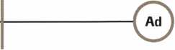

Keynotes

March 2000

|  |  |  |
| --- | --- | --- |
| Don-Jo Manufacturing, Inc. | Intellikey | Medeco Security Locks |
| P.O. Box 929 | 551 S. Apolo Boulevard, Suite 204 | P.O. Box 3075 |
| Sterling, MA 01564 | Melbourne, Florida 32901 | Salem, VA 24153 |
| (508)422-3377; FAX (508) 422-3467 | (800) 226-0703; FAX (407) 724-0811 | (540)380-5000; FAX (540) 380-5010 |
| ® # |  | • • • |
| Door Controls International | KABA High Security Locks | Meilink Safe Company |
| 2362 Bishop Circle East | P.O. Box 490 | 111 Security Parkway |
| Dexter, Ml 48130 | Southington, CT 06489 | New Albany, IN 47150 |
| (800)742-3634; FAX (800) 742-0410 | (860) 621-3601; FAX (860) 621-9727 | (800) 634-5465; FAX (800) 896-6606 |
| • • • • | e | • |
| ESP Lock Products, Inc. | KEY-BAK; Div. of W. Coast Chain Mfg. Co. | National Cabinet Lock |
| 375 Harvard Street | 1460 S. Balboa Ave. | 200 Old Mill Road, P. O. Box 200 |
| Leominster, MA 01453 | Ontario, CA 91762 | Mauldin, SC 29662 |
| (978) 537-6121; FAX (978) 534-9109 | (909) 923-7800; FAX (909) 923-0024 | (864) 297-6655; FAX (864) 297-9987 |
| • • | • • • • | o |
| Folger Adam Security, Inc. | Knaack Manufacturing Co. | Newman Tonks |
| 16300 W. 103rd Street | 420 E. Terra Cotta Ave. | 805 N Buckman St. |
| Lemont, IL 60439 | Crystal Lake, IL 60014 | Shepardsville, KY 40165 |
| (630) 739-3900; FAX (630) 739-6138 | (800) 456-7865; FAX (815) 459-9097 | (800) 826-5792; FAX (800) 777-8229 |
| • • | • | ® • |
| Fort Lock Corp. | LAB Security | ROFU International Corp. |
| 3000 N. River Rd. | 700 Emmett St. | 2004-B 48th Ave.; Court E |
| River Grove, IL 60171 | Bristol, CT 06010 | Tacoma, WA 98424 |
| (708) 456-1100; FAX (708) 456-9476 | (800) 243-8242; FAX (203) 583-7838 | (800) 255-7638; FAX (253) 922-1728 |
| •••••• | • | • • • |
| Grobet File Co. of America | LCN Closers (Division of Ingersol) | Rutherford Controls Inc. |
| 750 Washington Ave. | 121 W. Railroad Ave. | 2697 International Pkwy, Bid 5 #100 |
| Carlstadt, NJ 07072 | Princeton, IL 61356 | Virginia Beach, VA 23452 |
| (800) 962-7242; FAX (800) 243-2432 | (815) 875-3311; FAX (815) 875-3222 | (757) 427-1230; FAX (757) 427-9549 |
| * | e | • |
| H.E.S., Inc. | La Gard, Inc. | STRATTEC Security Corp. |
| 2040 W. Quail Ave. | 3330 Kashiwa Street | 3333 W. Good Hope Rd. |
| Phoenix, AZ 85027 | Torrance, CA 90505 | Milwaukee, Wl 53209 |
| (602) 582-4626; FAX (602) 582-4641 | (310) 325-5670; FAX (310) 325-5615 | (414) 247-3333; FAX (414) 247-3329 |
| • • • | • • • | • • • |
| HPC, Inc. | Lucky Line Products | Sargent & Greenleaf, Inc. |
| 3999 N. 25th Avenue | 7890 Dunbrook Rd. | P.O. Box 930 |
| Schiller Park, IL 60176 | San Diego, CA 92126 | Nicholasville, KY 40340-0930 |
| (847) 671 -6280; FAX (847) 671 -6343 | (619) 549-6699; FAX (619) 549-0949 | (606) 885-9411; FAX (606) 887-2057 |
| • • • | • | • • • • |
| HID Corporation | M.A.G. Engineering & Mfg. Inc. | Schlage Lock Co. |
| 9292 Jeronimo Road | 15261 Transistor Lane | 1915 Jamboree Suite 165 |
| Irvine, CA 92618 | Huntington Beach, CA 92649 | Colorado Springs, CO 80920 |
| (949) 568-1600; FAX (949) 568-1680 | (714) 891-5100; FAX (714) 892-6845 | (800) 847-1864; FAX (800) 452-0663 |
| <0 • | ^ <j^ | e e |
| Hongtai Lock Co. Ltd. | MARKS USA | Schwab Corporation |
| Jidong, Xiaolan Road, Xiolan | 5300 New Horizons Blvd. | 110 Professional Court |
| Zhongshan/Guangdong, China 528415 | Amityville, NY 11701 | Lafayette, IN 47905 |
| (86) 137-238-1414; FAX (86) 208-793-3856 | (516) 225-5400; FAX (516) 225-6136 | (765) 447-9470; FAX (765) 447-8278 |
| • • • • | e | • |
| llco Unican | MUL-T-LOCK USA, Inc. | Securitron Magnalock Corp. |
| 400 Jeffreys Road | 300-1 Route 17 South Suite A | 550 Vista Blvd. |
| Rocky Mount, NC 27804 | Lodi, NJ 07644 | Sparks, NV 89434 |
| (252) 446-3321; FAX (252) 446-4702 | (800) 562-3511; FAX (973) 778-4007 | (800) 624-5625; FAX (702) 355-5636 |
| ^ @ (p ^ | • II | • # |
| In Out Systems, Inc. | Master Lock Company | Security Door Controls |
| 3650-B Matte Boulevard | 2600 North 32nd Street | 3580 Willow Lane |
| Brossard, Quebec J4Y-2Z2, Canada | Milwaukee, Wl 53211 | Westlake Village, CA 91361 |
| (450) 444-5949; FAX (450) 444-4856 | (414) 444-2800; FAX (414) 449-3114 | (805) 494-0622; FAX (800) 959-4732 |
| e • | • • | 9 |
|  |  |  |

42**-**

March 2000

Keynotes

|  |  |  |
| --- | --- | --- |
| Security Solutions  1640 W. Hwy. 152  Mustang, OK 73064 (405) 376-1600; FAX (405) 376-6870  g) g g | DISTRIBUTORS | Direct Security Supply, Inc.  36 Lincoln Street  Boston, MA 02135  (800) 252-5757; FAX (800) 452-8600  © g © <$) © © © |
| Sentry Group  900 Linden Ave.  Rochester, NY 14625-2784 (716) 381-4900; FAX (716) 381 -8559  g | Accredited Lock Supply Co.  P.O. Box 1442  Secaucus, NJ 07096-1442 (800) 652-2835; FAX (201) 865-5031  g g g g g g g | Doyle Lock Supply  2211 W. River Road N.  Minneapolis, MN 55411 (800) 333-6953; FAX (612) 521-0166  ©©©gggggg©© |
| Sully Tools Inc.  3515 Nodding Pine Ct.  Fairfax, VA 22033  (703) 689-3416; FAX (703) 787-0869  g g (jjf | Ace Lock & Security Supply Co.  565 Rahway Ave.  Union, NJ 07083-6631 (800) ACE-LOCK; (800) ACE-FAX4  gggggggg | Dugmore & Duncan Inc.  30 Pond Park Rd.  Hingham, MA 02043 (888) 384-6673; FAX (888) 329-3846  g © g (0 © g © |
| Taymor Industries, Inc.  1586 Zephyr Ave.  Hayward, CA 94544 (800) 388-9887; FAX (800) 288-8133  g g | ADI  263 Old Country Road  Melville, NY 11747 (516) 692-1000; FAX (516) 692-3457  g g g | E. L. Reinhardt Co., Inc.  3250 Fanum Road  Vadnais Heights, MN 55110 (800) 328-1311; FAX (612) 481 -0166  © © (0 © © © |
| Trine Products Corporation  1430 Ferris Place  Bronx, NY 10461  (718) 829-4796; FAX (718) 792-9127  g g g | Akron Hardware Consultants, Inc.  2579 South Arlington Road  Akron, OH 44319  (800) 321-9602; FAX (800) 328-6070  g (p g | Ewert Wholesale Hardware  4709 W 120th St  Alsip II 60658  (800) 451 -0200; FAX (708) 597-0881  g (0 (0) © © |
| Unelko Security Systems Ltd.  14641 N. 74th Street  Scottsdale, AZ 85260 (480) 991 -7272; FAX (480) 483-7674  g | American Security Distribution  4411 E. La Palma  Anaheim, CA 92807 (714) 996-0791; FAX (714) 579-3508  g © g (fj g g © | Fairway Supply, Inc.  2631 Lombardy Lane  Dallas, TX 75220  (214)350-0021; FAX (214) 352-4299  © g g (0 © 0 © |
| Videx, Inc.  1105 NE Circle Blvd.  Corvallis, OR 97330 (541) 758-0521; FAX (541) 752-5285 | Andrews Wholesale Lock Supply  544 S. 9th St.  Lebanon, PA 17042-6608 (717) 272-7422; FAX (717) 274-8679  g | Foley-Belsaw Company  6301 Equitable Road  Kansas City, MO 64120 (800)821-3452; FAX (816) 483-5010  © (g) © © |
| W-Lok Corporation  675 East 16th Street, Suite 111  Holland, Ml 49423  (616) 355-4015; FAX (616) 355-4295  © | Boyle & Chase Inc.  P. O. Box 74  Accord, MA 02018-0074 (800) 325-2530; FAX (800) 205-3500  g g g | Fried Brothers, Inc.  467 N. 7th St.  Philadelphia, PA 19123 (800) 523-2924; FAX (800) 541 -3489  ©©©gggggg© |
| Weiser Lock Company  6700 Weiser Lock Blvd.  Tucson, AZ 85746  (502) 741 -6338; FAX (520) 741 -6363  g g | Clark Security Products, Inc.  4775 Viewridge Ave.  San Diego, CA 92123-1641 (800) 854-2088; FAX (619) 974-5284  gggggggggg | HS&S Wholesale Distributors  12915 West 8 Mile Road  Detroit, Ml 48235  (800) 521 -2202; FAX (313) 342-7580  g g © g © ® © |
| Wilson Bohannan Company  621 Buckeye Street  Marion, OH 43301-0504 (800) 382-3639; FAX (740) 383-1653  © | Cook's Building Specialties  2441 Menaul Blvd. NE; P.O. Box 37320 Albuquerque, NM 87176-7320 (505) 883-5701; FAX (505) 883-5704  g g g g g © | Hans Johnsen Company  8901 Chancellor Row  Dallas, TX 75247  (214) 879-1550; FAX (214) 879-1530  ©gggggg© |
| Yale Security Inc.  P.O. Box 25288  Charlotte, NC 28229-8010 (800) 438-1951; FAX (800) 338-0965  g g g g | DiMark International  3117 Liberator St., Unit A  Santa Maria, CA 93455 (800) 235-2435; FAX (805) 928-8034  0 10) g (S| © | Hardware Agencies, Ltd.  1220 Dundas Street East  Toronto, ON M4M 1 S3 (416) 462-1921; FAX (414) 462-1922  ©gggggg© |
| Zhongshan Hua Feng Lock Products  S Yongning Industrial Road, Ziaolan Zhongshan Guangdong, China  86-760 227 82 63; FAX 86-270 227 80 63  © | Dire's Lock & Key Co.  2201 Broadway  Denver, CO 80205  (303) 294-0176; FAX (303) 294-0198  ggggggggggg | Hardware Suppliers of America  P.O. Box 2208  Winterville, NC 28590 (800) 334-5625; FAX (800) 334-5635  gl © |

Keynotes

March 2000

|  |  |  |
| --- | --- | --- |
| IDN, Inc.  1000 S. Main, Suite 280  Grapevine, TX 76051 (817)421-5470; FAX (817) 421-5468 | Securite.com  4775 Viewridge Avenue  San Diego, CA 92123 (800) 241-3930; FAX (619) 974-5269  (0 g g | Webster Safe & Lock Company, Inc.  3020 Millbranch  Memphis, TN 38116 (901) 332-2911; FAX (901) 332-2878  g g g g g g g |
| Intermountain Lock & Supply Co  3106 South Main Street  Salt Lake City, Utah 84115 (800) 453-5386; FAX (801) 485-7205 | Omaha Wholesale Hardware  1201 Pacific Street, PO Box 3628  Omaha, NE 68108 (800) 238-4566  gggggggg | SERVICE |
| JLM Wholesale, Inc.  3095 Mullins Ct  Oxford, Ml 48371-1643 (800) 522-2940; FAX (800) 782-1160  (gi © | Security Lock Distributors  40 A Street  Needham Heights, MA 02194 (800) 847-5625; FAX (800) 878-6400  g g g | 1 -(800) Tow Truck, Inc.  190 Main Street  Hackensack, NJ 07601 (800) 835-4187; FAX (800) 835-4189 |
| Jo-Van Distributors Inc.  929 Warden Ave.  Scarborough, Ontario Ml L 4C6 (416) 752-7249; FAX (416) 752-3845 | Sentry Security Fasteners  8109 N. University  Peoria, IL 61615  (309) 693-2800; FAX (309) 693-2872  © © | Alarm Monitoring Service, Inc.  5021 Fairfield St.  Metairie, LA 70006 (504) 454-2163; (504) 456-8737  © |
| Lockmasters, Inc.  5085 Danville Road  Nicholasville KY, 40356 (800) 654-0637; FAX (606) 885-7093  lg) (£) (j) | Southern Lock and Supply Co.  Box 1980, 10910 Endeavor Way  Pinellas Park, FL 33780 (800) 237-2875; FAX: (800) 447-2299  ggggggggg | Allstate Insurance Company  2775 Sanders Road, Suite A5  Northbrook, IL 60062 (847) 402-8196; FAX (847) 326-7509  © |
| Locks Company  2050 N.E. 151 St.  N. Miami, FL 33162 (800)288-0801; FAX (305) 949-3619  ^}i <u> (|j (g) ^ | Stone & Berg Wholesale  99 Stafford Street  Worcester, MA 01603 (800) 225-7405; FAX (800) 535-5625  gggggggggg | Diamond Software  2952 N. Expressway  Griffin, GA 30223  (770) 227-7650; FAX (770) 227-1699  $ |
| The Locksmith Store Inc.  1229 E Algonquin Rd. Suite E  Arlington Heights, IL 60005 (847) 364-5111; FAX (847) 364-5125  ||J) (j^ 0 | Strauss Safe & Lock Company  1801 Second Avenue  Des Moines, IA 50314 (515)288-9571; FAX: (515) 288-9752  © g (0 g g g | Locksmith Publishing Corp.  850 Busse Hwy.  Park Ridge, IL 60068 (847) 692-5940; FAX (847)692-4604  © |
| M. Zion Company  69 Reade Street, 4th Floor  New York, NY 10007 (212) 349-8677; FAX (212) 964-0495  ® U) @ 10) (0 (g) (jjt | Tanner Bolt & Nut Corporation  4302 Glenwood Road  Brooklyn, NY 11210 (718) 434-4502; FAX (718) 434-3215  ® | The National Locksmith Magazine  1533 Burgundy Parkway  Stream wood, IL 60107 (630) 837-2044; FAX (630) 837-1210  © |
| McDonald-DASH Locksmith Supply  5767 E. Shelby Dr.  Memphis, TN 38141 (800) 238-7541; FAX (901) 366-0005 | Timemaster, Inc.  127 SE 29th Street  Topeka, KS 66605  (785) 232-8705; FAX (800) 798-8463  g g g g g g g | Pine Technical College  1000 4th Street  Pine City, MN 55063 (800) 521 -7463; FAX (320) 629-7603  © |
| McManus Locksmith Supply, Inc.  P.O. Box 9231, 1309 Central Ave.  Charlotte, NC 28299 (702) 333-9112; FAX (704) 332-8664  © © (g) (£j) | Top Notch Distributors, Inc.  3151 Goni Rd.  Carson City, NV 89706-7922 (800) 722-4210; FAX (800) 248-3620  g (0 g | SecurityEdge.com  PO. Box 990  Exeter, NH 03833  (603) 772-6645; FAX (603) 778-7265  © |
| McMaster-Carr Supply Company  600 County Line Rd,  Elmhurst, IL 60126-2081 (630) 833-0300; FAX (630) 834-9427  |g> (g (jj g | Turn 10  P. O. Box 746  Marietta, OH m45750 (800) 848-9790; FAX (800) 391 -4553  g ^ | © Alarms  ® Bank Security Equipment ® Automotive ® Builders Hardware ® Business/Tech & Ed.  © CCTV/Photo Imaging ® Electric/Electronic Security ® Lock Devices © Tools & Supplies © Safes/Vaults ® Other |
| Monaco Lock Co.  339-345 Newark Ave.  Jersey City, NJ 07302 (800) 526-6094; FAX (800) 845-LOCK  g g g | U.S. Lock Corporation  77 Rodeo Drive  Brentwood, NY 11717 (800) 925-5000; FAX (800) 338-5625  g g g g g |
|  |  |

March 2000

Keynotes L

Keynotes

Authors



Dept |

Paul Chandler, CRL, is the manager of the Electronic Security Department for I.D.N. - ACME in Houston, TX. He was “Keynotes Author of the YeaY in 1998 and is currently a contributing editor.

Donald B. Dennis, CPL has been dealing with the Locksmithing profession since 1972 with a four year

apprenticeship in Albuquerque, New Mexico. He founded and has been the owner of Dennis Safe & Lock in Johnson City, Tennessee since 1977. He was the founder of the East Tennessee Locksmith Association in 1988 and is currently the Chairman of the Education Committee and editor ofETLA Newsletter.

It's True

Marray has developed the first  
screwless door loop.

Aluminum ma­terial means true anodizing.

No off color powder coat­ing or painting

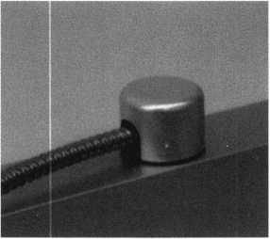

Standard 18” length. Can be ordered in cus­tom lengths

Plastic base stops shorts and pro­tects wires

Screwless base and cap means you drill two 1/2 inch diameter holes, pop the base into the hole, wire your system and snap on your covers. Simple as 1,2, 3.

**Here’s the best part we are giving away a**

FREE SAMPLE TO THE FIRST lOO CALLERS WHO MEN­TION THIS ADD. A $14.40 WHOLESALE PRICE VALUE.

CALL TODAY, IT’S FREE!!

1-800-500-1449

Marray *enterprises, inc.*

**At** Marray, **we’re not just modifiers, we’re Master Hardware Modifiers™**1128 Walsh Ave., Santa Clara, CA 95050. [www.marray.com](http://www.marray.com)

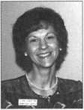

Claire L. Cohen, the second

woman to become a CML, has been in locksmithing  
since 1977 and has been writing articles for  
Keynotes since 1987. She is also a contributing  
editor for Keynotes.

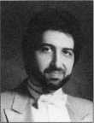

Sal Dulcamaro, CML, has been

in the locksmith business for over 24 years. He is the  
president of All Pro Security, Inc. in Michigan and  
has been an AL0A member for 17 years. A past  
president of the Locksmith Security Association of  
Michigan. Sal currently serves as editor of the  
association newsletter. He was named “Keynotes  
Author of the Year’’ for 1996 and 1997. He is  
also a contributing editor for Keynotes.

1K2

***\*W\***

*—Mike* Terrill is a third generation locksmith, who lives on the Island of Nantucket in Massachusetts.

Keynotes

March 2000

**Gizmos, gadgets, widgets and**

Gear up for six exciting days of safe and vault technology. You'll see it all at SAFETECH 2000 -even things you've never seen or heard of before! Plus, the experts will be on hand to answer questions, give demonstrations, and offer training in every area. With over 24 conveniently scheduled classes, and many exhibitors, SAFETECH 2000 is your source for the information and skills you need to take your career into the next millennium.

While you're there you can also enjoy the city known for its industriousness, as well as good ol' Southern hospitality. Tour the Sloss Furnaces, which earned the town the moniker "Iron City;" visit the Mercedes Benz factory or any of a number of museums; or explore the richly wooded foothills and mysterious caverns of the Appalachian Mountains.

Join us May 1 through 6  
for SAFETECH 2000.

For more information call

214.827.7233,

or visit our website at

[www.savta.org](http://www.savta.org)

**SAFETECH2000**WE'VE GOT **THE WORKS**

March 2000Keynotes

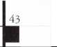

**Back**

Page

Dept

*t*



_j

ENTER NOW!

THE FIRST-EVER "BEST YELLOW PAGES AD"CONTEST

ALOA and the Yellow Pages Publishers Association (YPPA) have joined forces to present the first-ever “Best Yellow Pages Ad” Contest.

The contest is open to all ALOA members. Submissions will be judged by executives at YPPA on the basis of ORIGINALITY, GRAPHIC DESIGN, and MESSAGE CONTENT within the following entry categories:

BEST USE OF “IDEA" THEME: Does your ad give customers ideas?

PROOF OF RETURN ON INVESTMENT: How has your ad brought in customers and resulted in purchases?

MOST INFORMATIVE AD: Do you go the extra mile to provide customers with the information they need?

BEST USE OF COLOR AND ILLUSTRATIONS: Does your ad have an added creative flair? Does your ad jump off the page?

Please submit ad as it appeared in your directory.

Please specify which category you are entering (for “Proof Of Return on Investment” please include pertinent data).

Please specify which directory your ad appeared in as well as the code on the spine of the book

The winners will have their ads reprinted in an upcoming issue of Keynotes and will receive a $100 rebate from YPPA on their next Yellow Pages ad. Winners will be announced during the ALOA convention in July 2000 at a special Yellow Pages educational workshop.

Deadline for entries is April 30, 2000

SUBMIT ENTRIES TO LISA METZGER, SCHENKEIN,

1125 17TH STREET, SUITE 1200, DENVER, COLORADO, 80202

***Keynotes***

March 2000

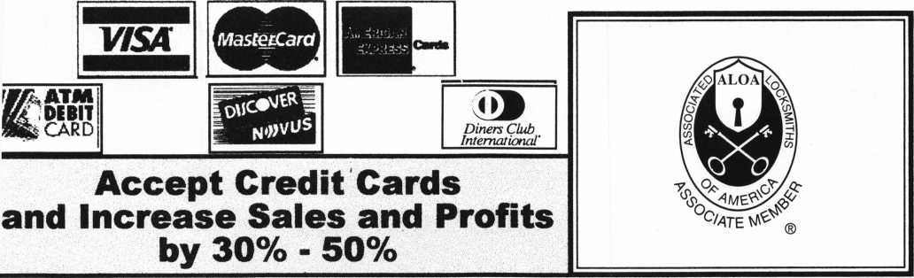

There are three reasons why people don’t accept credit cards:

"hrough Association Benefits **^** 1. Too expensive,

liese Concerns Are Eliminated 2. The paperwork hassle.

“ 7" 7 " I 3. Inability to qualify.

Here’s how it works: |

* Simply swipe or enter the credit card #.
* Enter amount of sale. i\« Hassle - Easy Qualifying
* Approval within seconds.
* Funds wired electronically into your local checking account within 48 hours.

because of your association membership, nearly 100% of all retail and home based applicants

will be approved even with past credit problems.

Currently Processing Merchants Please Read

Monthly Lease To Own Set-Up Options

Special Low Discount Rate and Transaction Fee: 1.59% + 20<t  
Dlus Monthly Statement!Customer Service Fee: $10

Package A: $29.95 Terminal  
Package B: $39.95 Terminal & Printer In One

Deluxe Package C: $49.95 Portable Terminal/Plinter/Pin Pad  
Debit acess fee Ability to Accept Visa/MC “Check Cards”

$ 10/mo. & ATM Cards at a FLAT 250

Totally Eliminating the 1.59 % Rate  
(All lease terms 48 months • Monthly minimum $25)

] I authorize Universal’s sales office to print and deposit a check  
in the amount of $49 (normally $ 125) for my application fee which

covers initial materials, application processing, equipment warranty,

shipping & handling, programming, installation and training.

Fill out a check, tape here above mini form and then fax.

Fax Express Mini Form Now To **1 -800-439-7773**

Receive a c- ^r°9r3/7t FopP^ ^e<

foods

will

Qo of

' ~ 'ety-

yottri

***?££*<**

tcaforate

to

ZC*BD'*°ttoagj,o*

E£S!

Company Name. Contact Name _

Address

City

State -

Zip.

Phone

BestTime

Signature.

New Account Set-up Options (Check)

Package A I—I Package B □

Deluxe Package C I—I

Free Pin Pad Program For Currently Processing Merchants □

A subsidiary of Universal Savings Bank, FA.

Marketing Office 1-800-836-4295

Universal Payment Processing Provides 24 Hour Live Customer Service.

To naviga  
your locksmithii  
enterprise into t

next millennium y<

need the latest trainin  
product information, ar  
tools. You can explo  
the entire locksmithir  
universe at one gre  
show—ALOA 2000  
Las Vegas, Nevadi

You can also beam aboar  
the Las Vegas HiIton  
newest attraction-  
Star Trek: The Experience

For more informatio  
visit our website <  
http:/ / [www.aloa.org](http://www.aloa.org)  
and plan to boldl

go to ALOA 200(

